






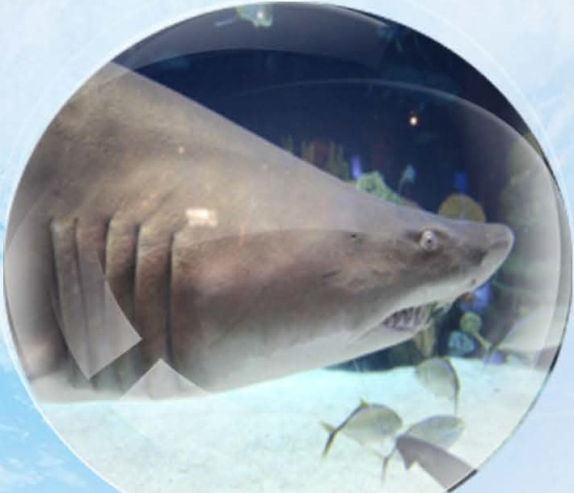





Carcharias Taurus



C O,\leall1 TlIMAK..'- \&'O

RED
11S1

CM,e,,J•'r c...-
 .D P'tO .. C -.b
-

"' 00 I.C
,..
Do Olf Ca Ut



Threats
Ov rfishing, around 100 million sharks are killed every year for their fins
Habitat where they liue
The can be found 1n warm or tern erate waters all around the war ds oceans, except the eastern acific


Diet what the eat


Fish, Squid an= Crustaceans

Life span how long they liue for
15 or more years
Size:
Between 2 and 3 metres
Breeding:
 owza-c:>



emales are typical larger than males and give birth to two live young on average every two years


The Sand Tiger Sharks at SEA LIFE London Aquarium are
called Zippy and Bungle!




■

London Aquarium

