Torture in the

Learning Objectives
PuPils should learn:
Why torture has been used for thousands of years.
About some of the instruments used to torture people in the Middle Ages.

Dungeon Links

Middle Ages
Torture in the Middle Ages is a key topic which features throughout the Dungeon.

Using the Pupil Worksheets
Pupils work with images of torture implements from the Middle Ages. They should consider how and why they were used and their effects within the context of history.

PuPil Worksheet 1 asks pupils to work in groups to rate a selection of medieval torture implements according to which they believe to be the most painful on a scale of 1 – 5. They are also tasked with writing a job advertisement for
a medieval torturer.
PuPil Worksheet 2 features a number of word and picture cards that can be used in one of two ways. You will need to photocopy enough sets of the cards for pupils to work in either groups or pairs, depending on which model you use for the activity. Each set of cards will need to be cut out. Then either:
- working in groups of three or four, pupils look at a number of images of torture implements and match them to descriptions of what they do.
Or
- working in pairs, give one pupil a picture card and their partner the description. The pupil with the picture card must ask their partner questions which can only be answered ‘yes’ or ‘no’ (in the style of 20 questions), in order to deduce what the torture

Extension Activities
You might like to run a hot-seating activity where you play a medieval torturer and the class can ask you questions, which you answer in character.
Ask pupils to investigate the modern day judicial system. Ask them to research the alternative punishments to torture nowadays, for example the electronic bracelet.

Discussion Points
Discussion Points
Under what kind of circumstances might these horrible torture devices have been used?
Under what kind of circumstances might these
horrible torture devices have been used?
Why was life in the Middle Ages so much harder than it is now?
Why was life in the Middle Ages so much
harder than it is now?
(You may need
(You may need to give clues or
to give clues or
headings to guide
headings to guide discussion here.)
discussion here.)
How do people nowadays think about torture compared
How do people
nowadays think
about torture
compared
to how they
to how they thought about it in the Middle Ages?
thought
about it in the
Middle Ages?

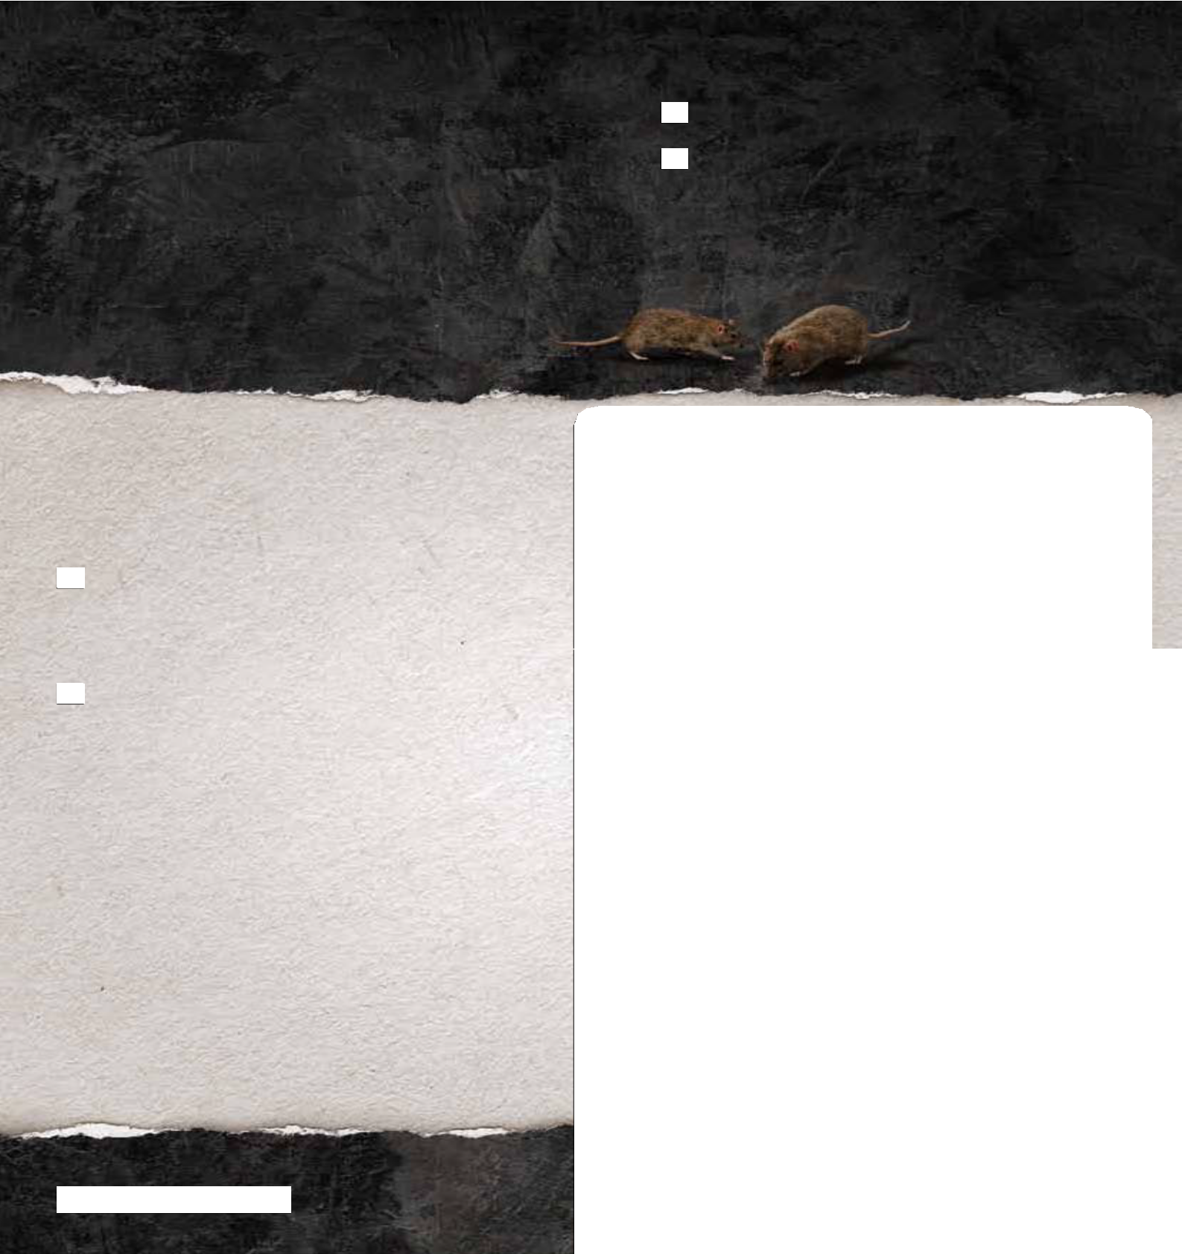
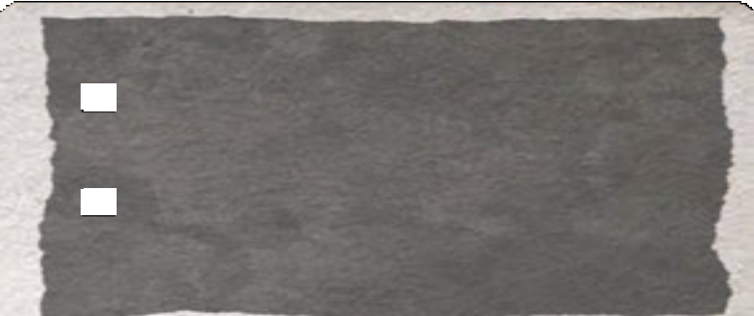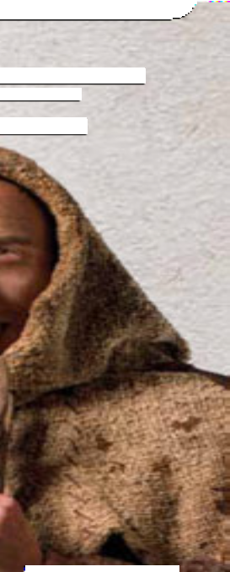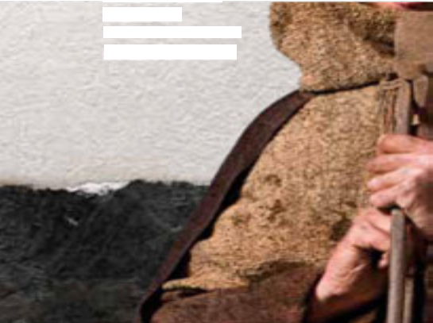

TEACHER NOTES
thedungeons.com

Torture in the Middle Ages
Torture has been used for over 2000 years, and so its origins have been lost in history. However, most of the world’s civilizations have used torture as a way of punishing their victims or to find out information. Many of the instruments of torture you will see in the Dungeons have been around for hundreds of years, and they still have the power to make you shiver.

The Cage
Paying for torturers and equipment was expensive. Because of this, the basic metal cage was quite popular.
The victim was simply locked inside, pulled up on a chain and left for as long as was required depending on the crime.

The Head Crusher
This machine was made of metal and was helmet shaped and held the victim’s head still.
A cap on top was forced down by a powerful screw mechanism, shattering the bones of the
skull. Unsurprisingly, it often caused death.

The Saw
Specialised instruments were expensive and not always available, so everyday tools were often used instead. The saw was an example of this. Victims would have various limbs or toes or fingers sawn off depending on what they had done.

The Wheel
There were many different versions of this punishment. Often it involved a near-naked victim being tied across a large cart-wheel. The torturer, with a heavy hammer, then smashed the bones in every limb and joint of the victim, without causing death.

The Heretic’s Fork
eligious men used this fiendish device to stop heretics (a person who held beliefs that were not those of the Catholic church) from saying something they did not want to hear. This double fork, with two sharp prongs at each end, was placed between the victim’s lower jaw and breastbone and held in place with a collar, so if they spoke, they would wound themselves badly.
Religious men used this fiendish device to stop heretics
a person who held beliefs that were not those of the
atholic church) from saying something they did not
want to hear. This double fork, with two sharp prongs
t each end, was placed between the victim’s lower jaw
nd breastbone and held in place with a collar, so if
hey spoke, they would wound themselves badly.

Activity 1
in groups, rate the medieval torture implements above according to which you believe to be the most painful on a scale of 1 – 5

Activity

imagine that you have been asked to write a job advertisement for a medieval torturer. Write about 50 – 200 words. You
2
you have been asked to
vertisement for a medieval
about 1
5
0 – 200 words. You
this as a poster or a billboard.
could present this as a poster or a billboard. Make sure you include information about:
u include information about:
or

(1 being painful and 5 being
what the t

rturer’s main responsibilities will be

death imminent!)

who he w ll be working with
what kind of personality might suit the role previous experience required
ill be working with
of per
sonality might suit the role
xperience required

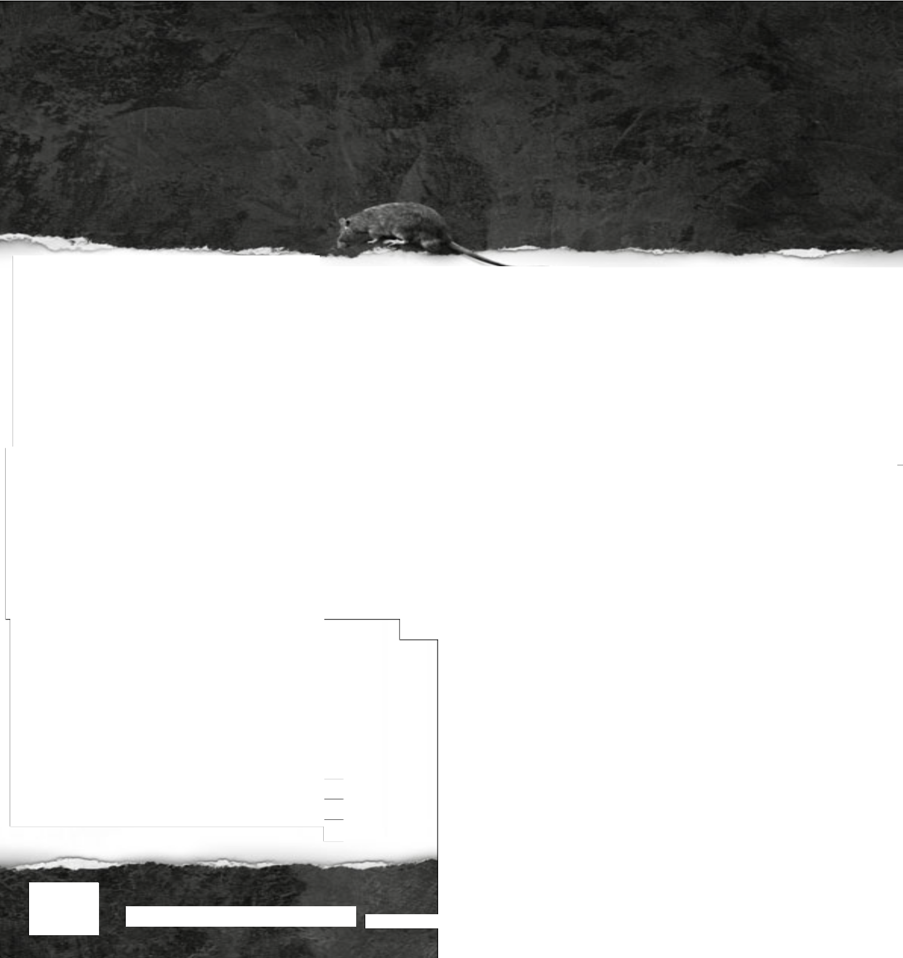
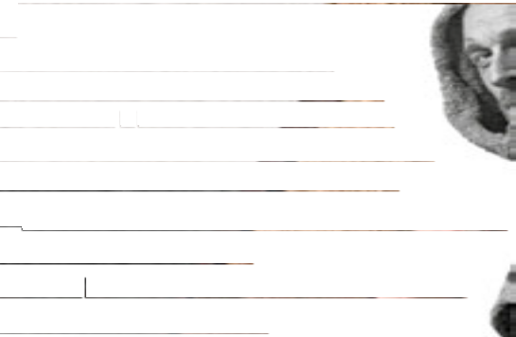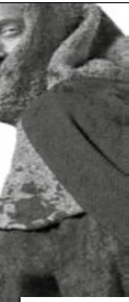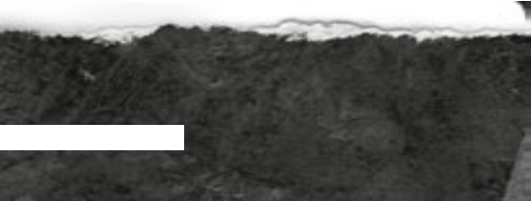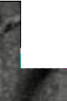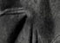Torture in
PUPIL WORKSHEETS:
1
he Middle Ages

thedungeons.com

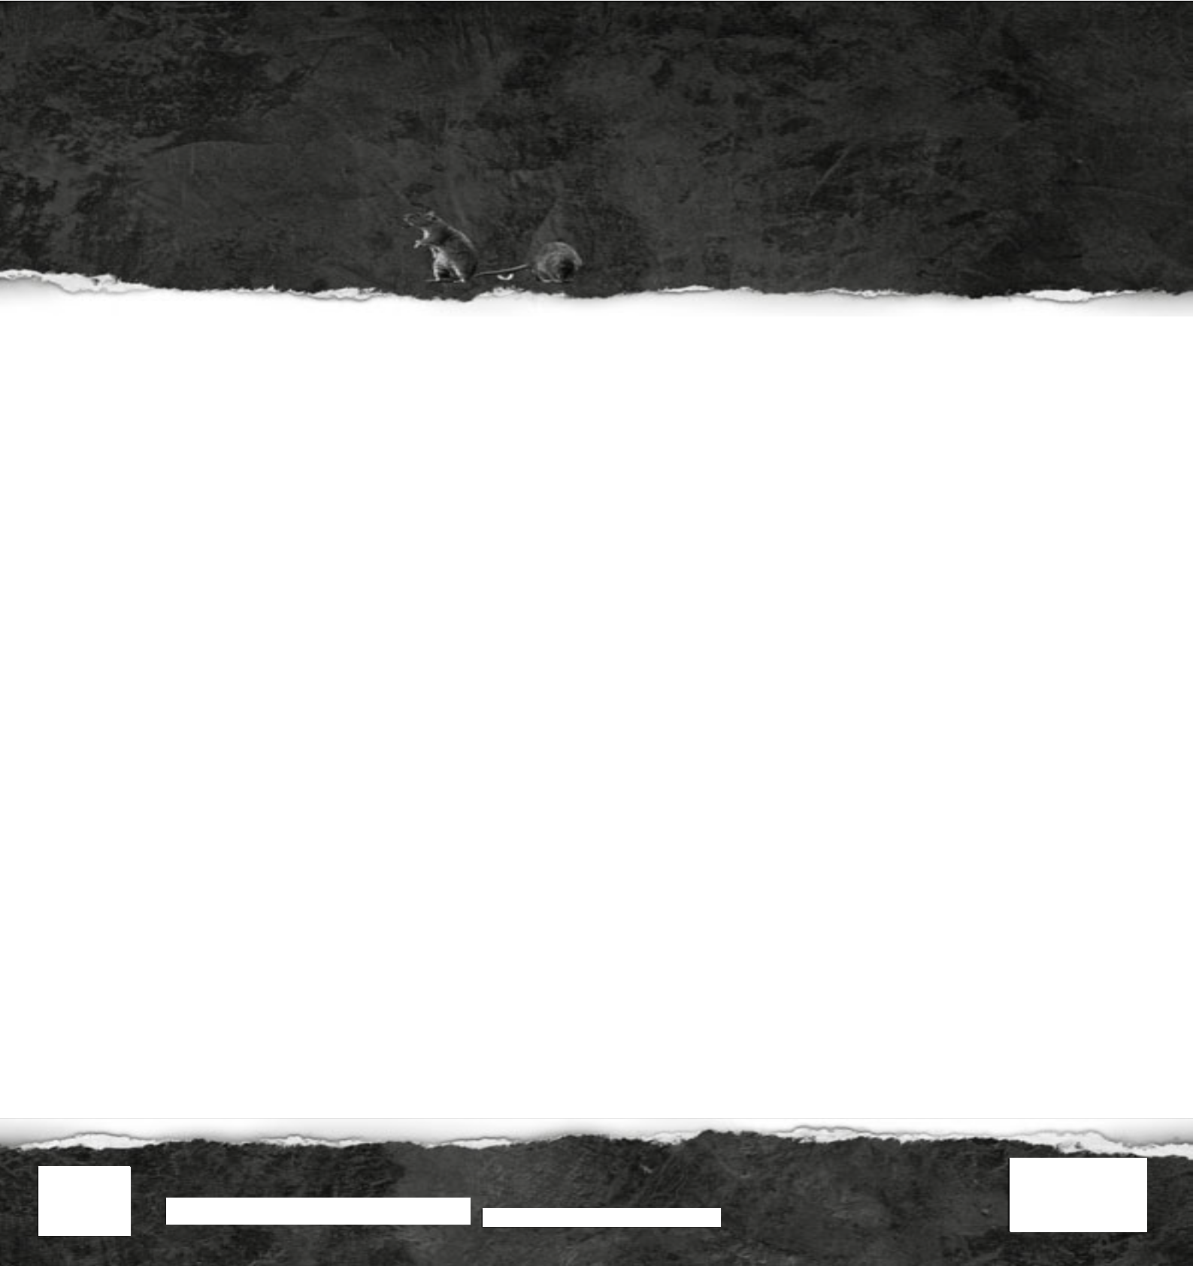
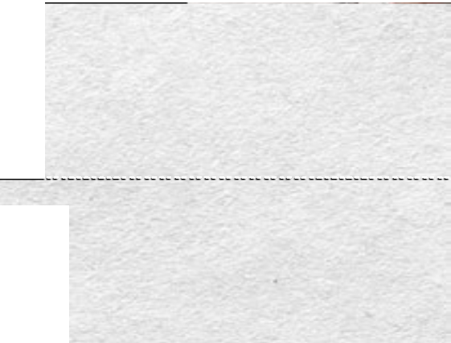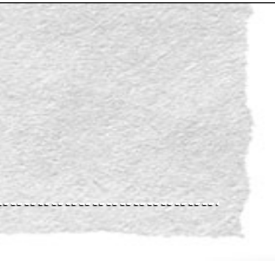

Torture in the Middle Ages

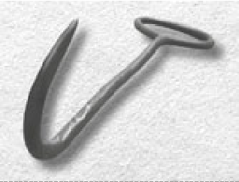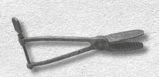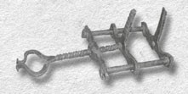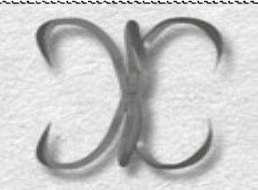Instruments of Torture

The Hook | The fact that you could use this tool for lots of different things made it a torturer’s favourite. Victims might simply be hung on it with wrists tied together or upside down by the ankles. It could also be used with its point placed at different parts of the body to cause varying degrees of pain – beneath the jaw or through the ribs. It was also ideal for gouging eyes, dragging out entrails, or simply raking the skin.
The Tongue Tearer | Removal of all or part of the tongue has been a common form of torture or punishment since biblical times. This medieval instrument, sometimes with  its jaws red hot, was used to pull the tongue as far forward as possible before cutting it off. The operation had varying degrees of success and a sharp knife was often needed as well. Splitting and piercing of the tongue were other versions of this punishment.
The Jaw Breaker | This grisly device worked a bit like a workshop vice or clamp. Its upright metal jaws were placed on either side of the victim’s own jaw, and the screw turned to bring them together, at a speed chosen by the torturer. When the victim’s jaw was particularly tough, a rod would be inserted through the loop in the screw to provide additional force. Other crushing devices included the well known thumbscrew.
The Claw | Ripping, tearing and digging into flesh is one of the most basic forms of torture. This implement, also known as the Ungula and the Spanish Spider,  emulated the talons of raptors and the claws of bears and other wild creatures. It came in many shapes and sizes. Its main purpose was to inflict terrible wounds to the arms and legs.


2
PUPIL WORKSHEETS:
Torture in the Middle Ages
thedungeons.com

