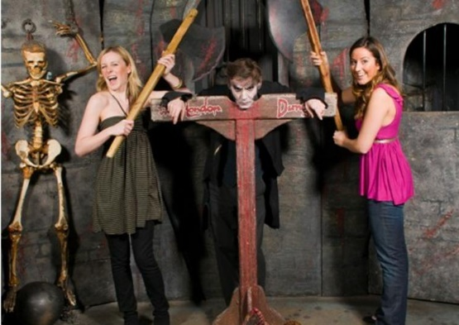
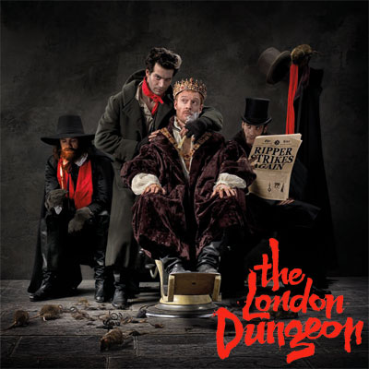
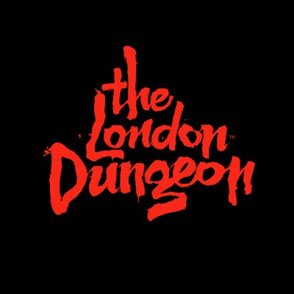


Read through the activities and answer as many questions as possible.
Have a go a designing your own London dungeon scene.
The London Dungeon is a uniquely thrilling attraction that will whisk you way back to the captain’s most perilous past. See, hear, feel and (ahem!) smell the chillingly amusing characters of the ‘bad old days’ as they come to life before you.

www.thedungeons.com/london/whats-inside/what-is-the-dungeon

London Dungeons

