The Great Fire of London

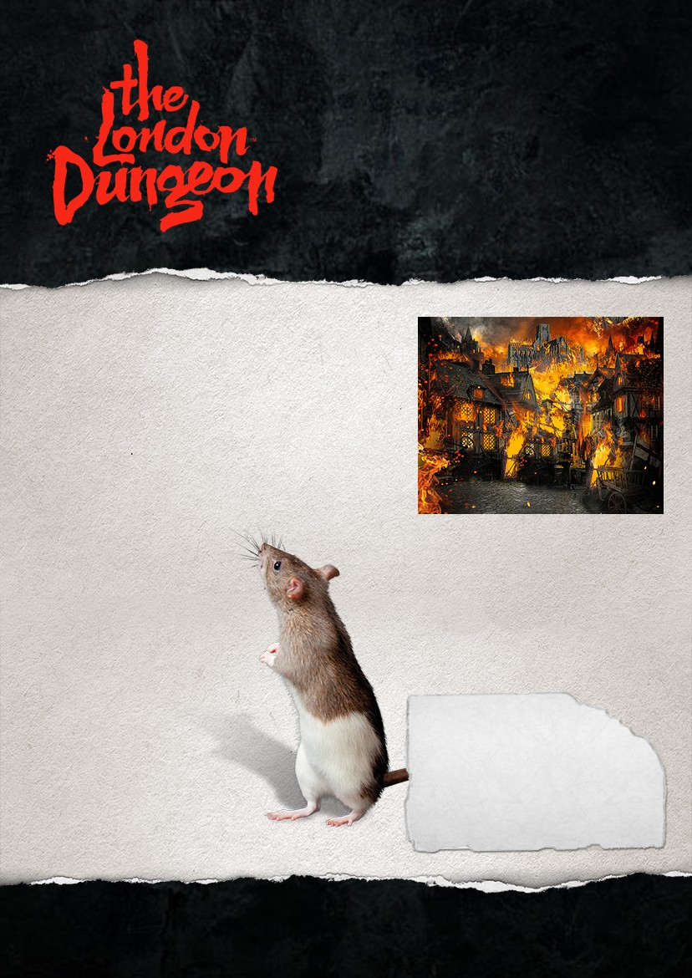Who was to blame for the Great Fire of London?
This worksheet is designed to give your pupils an understanding of the suspected causes and effects of the Great Fire that raged through London in 1666, which was a significant turning point in British History.

Using the Pupil Worksheets:
This activity is set out as a mystery and gives students the opportunity to work together and develop thinking skills. They will need to link together information about the causes of The Great Fire of London.
- Students will need to be in small groups and be given the set of statement cards in the worksheets overleaf.

- They should start by reading the cards and attempting to link the cards together. Not all cards are relevant to solve the mystery and there are many different ways of sorting the cards.

- They should be able to build up a picture of the causes of The Great Fire of London; some students may find it easier at this stage to make a list or mind map connected ideas.

Extension Questions:
- What actions could have prevented or reduced the effects of the fire?
- How important was the role of the Mayor of London in fighting the fire?
- Robert Hubert was found guilty of starting the fire and was hanged - do you think he was to blame for the Great Fire of London?

Learning Objectives
Pupils should learn about:

- Thinking and communication skills
- Causes and aftermath of the Great Fire of London
- State and society in the 1600s
- A significant turning point in British History

According to the Captain of a ship (The Maid of Stockholm), Robert Hubert arrived in London on 4th September 1666.
There was no police or fire brigade in London - only groups of local people known as the trained bands, who looked out for fires.
The narrow streets in London quickly became crowded with people moving their belongings to flee the fire.

Water wheels under London Bridge pumped water across the city.
The first person to die in the fire was a maidservant of Thomas Farriner - who refused to jump to the next wooden building.
Later on Sunday the King gave the order to
pull down houses to stop the fire.

The wind changed direction and on Wednesday 5th September the fire finally burnt itself out.
St Paul’s Cathedral was made of stone, with open spaces surrounding it, so was considered safe.
The lead on the roof of St Paul’s melted and this hot metal ran down the streets.

The lightermen who worked in the boats on the River Thames increased their prices for people who wanted to escape across the river.

Robert Hubert, a French Watchmaker confessed to having deliberately started the fire at the bakery, by throwing a fire grenade through the open window.
People stored their possessions in stone buildings, including many churches and cathedrals.

Thomas Farriner initially stated that he was sure the ovens were put out before he went to bed.
St Paul’s Cathedral was undergoing restoration and was covered in wooden scaffolding.

The fire destroyed 13,200 houses and 84 churches, which today would be over one billion pounds worth of damage.

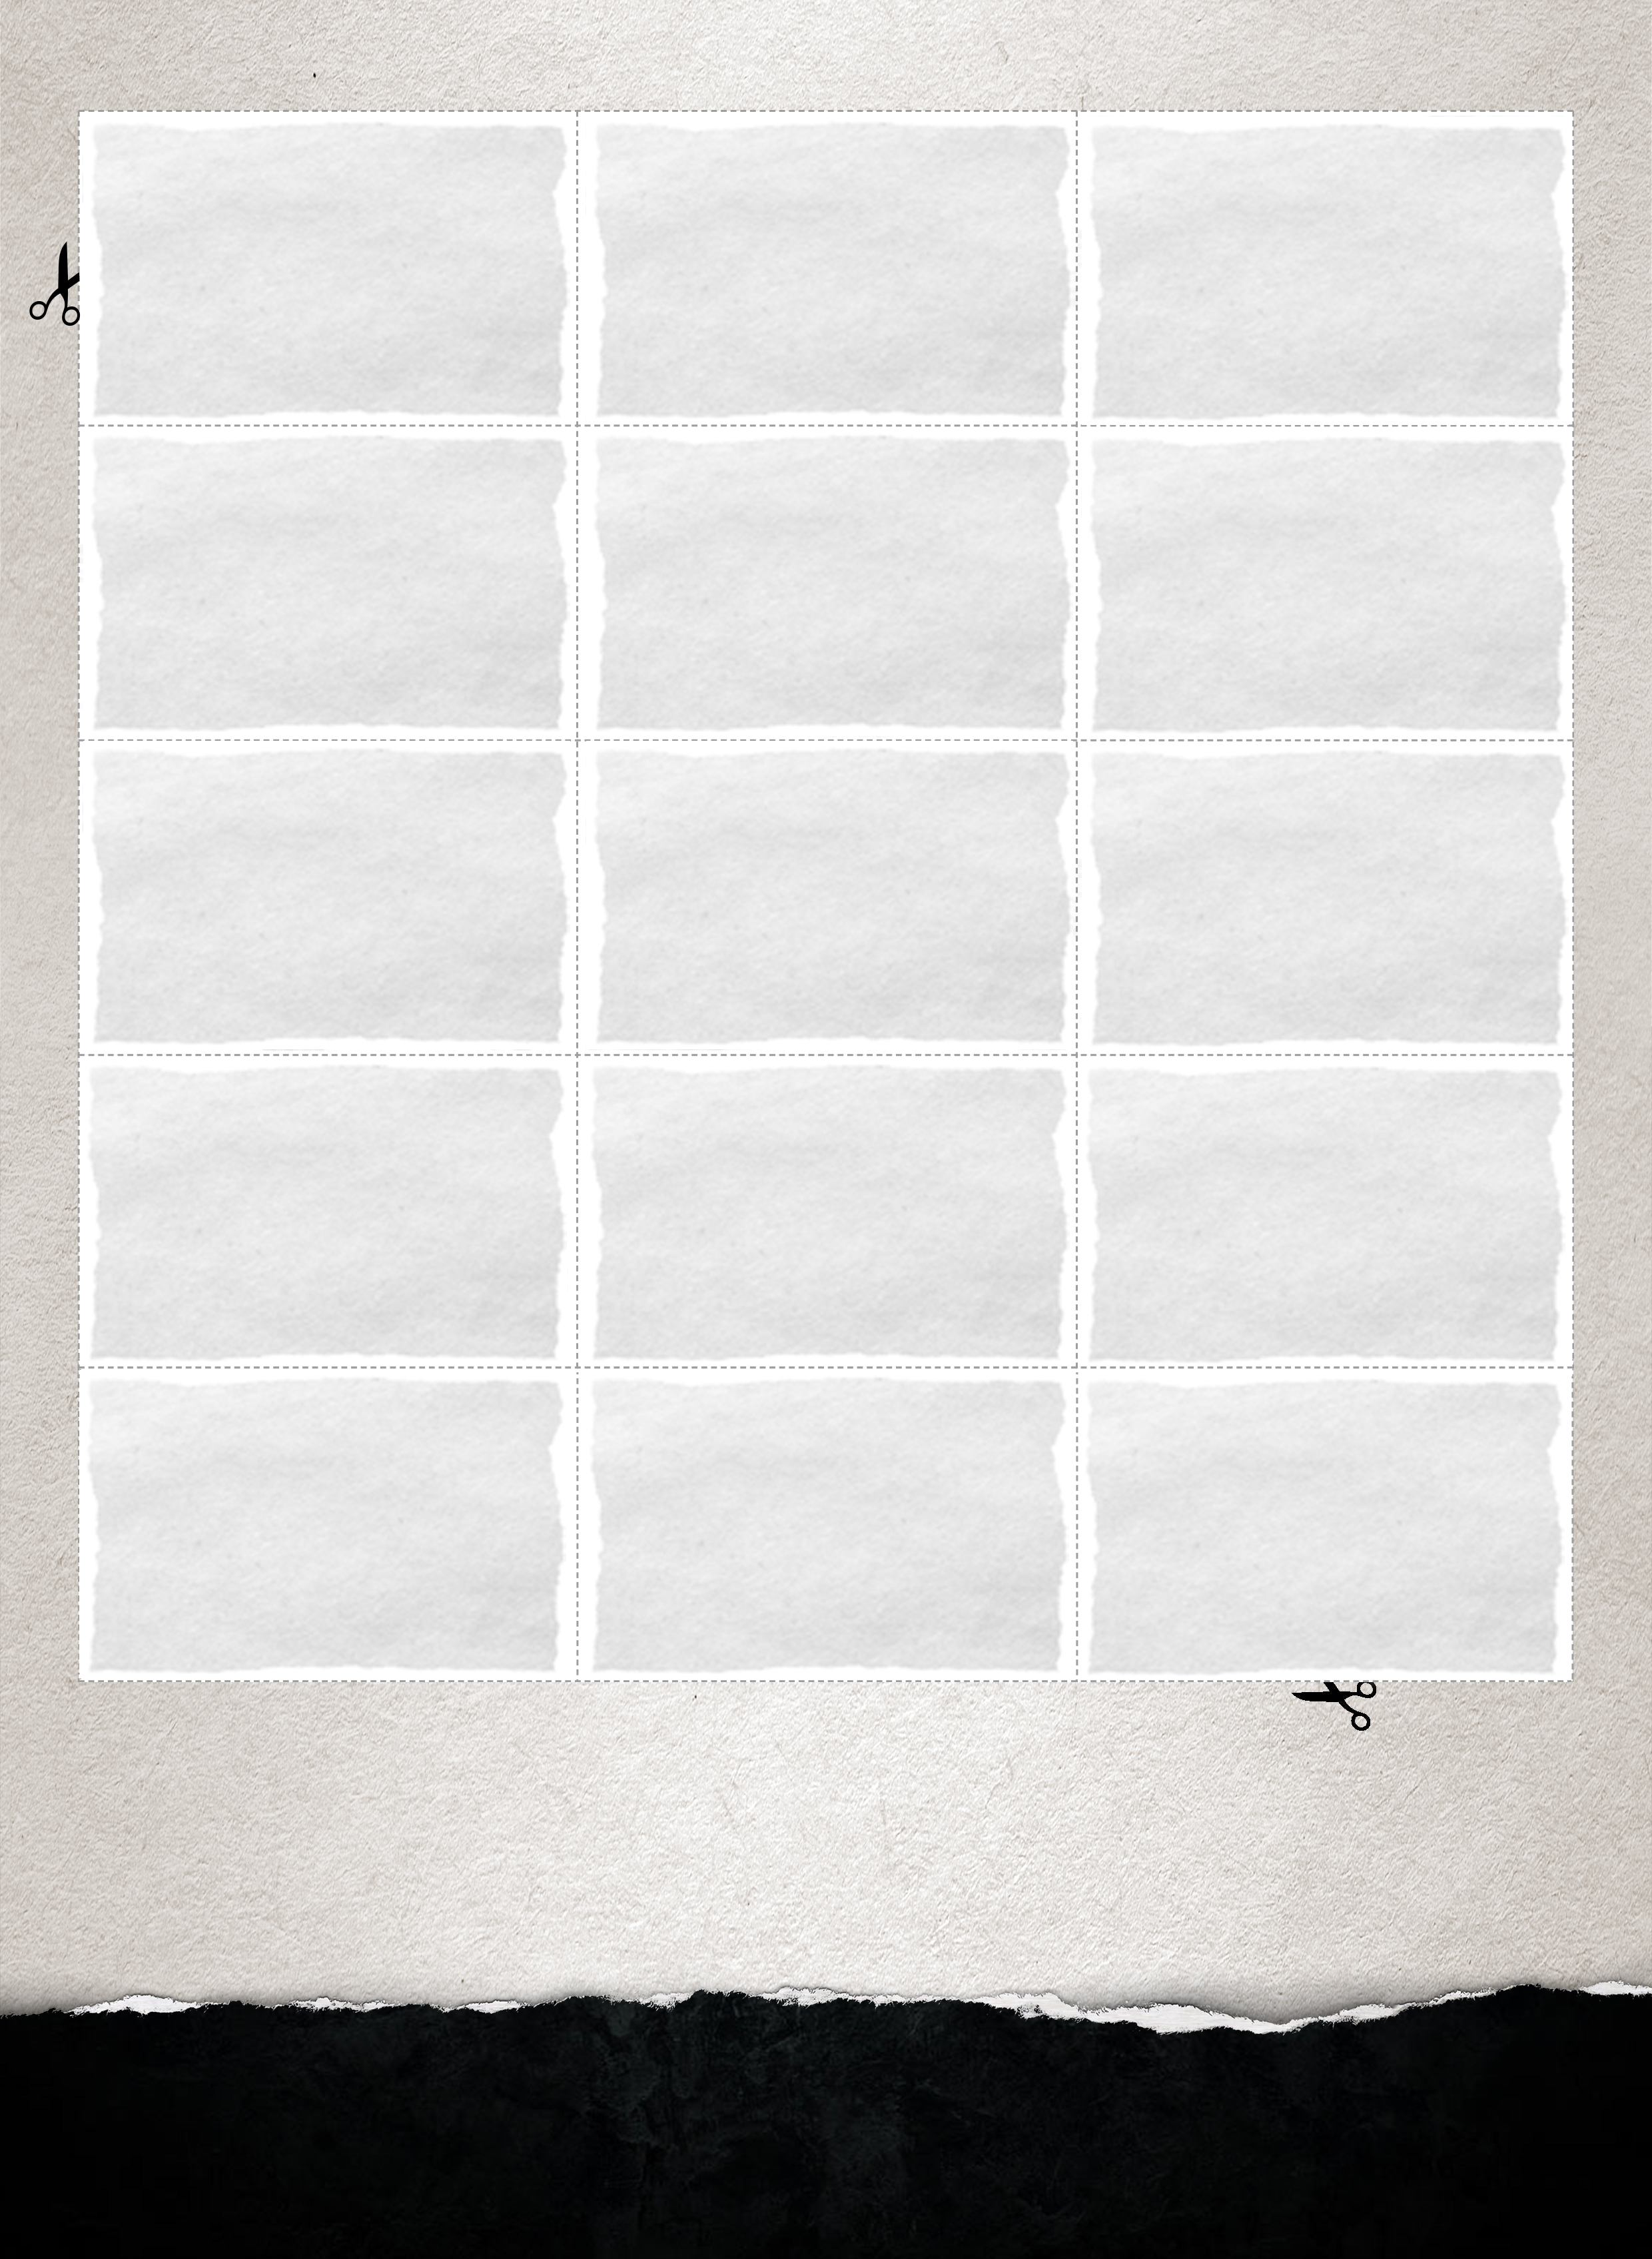

PUPIL WORKSHEET: The Great Fire of London

Thomas Farriner was the baker to King Charles II of England. He produced a range of breads, baked in his ovens.
Bakery ovens were heated by fire, which needed to be lighted early each day before the bread could be cooked. Most bakeries burnt sticks and straw.
July and August 1666 were very dry months and very little rain fell in London.

To light a fire people would use a Tinderbox, by striking a flint against a steel box, which then set straw on fire.

England was at war with the French and the Dutch at the time of the fire.
At 2:00am on Sunday 2nd September, workmen at Thomas Farriner’s bakery smelled smoke and woke the household.

When the Mayor, Sir Thomas Bloodworth heard of the fire, one hour after it started he was not concerned saying that "a woman might piddle it out"
In April 1665 King Charles II warned the Mayor of London that London was in danger of a fire, caused by narrow streets and overhanging timber houses.

Most houses in London, including those on London Bridge were made of wooden timbers.

Firebreaks (gaps between buildings) can help to contain fires.
However there were not many of these in London.

To fight fires they used long sticks with hooks on the end to pull down buildings surrounding the fire.
In 1632 they had created a firebreak on London Bridge to prevent fires spreading along the bridge.

In the event of a fire the Mayor of London could not pull down houses without being made personally responsible for the cost of rebuilding them, unless he had the King's permission.
Lots of local people blamed the fire on foreigners, in particular the Dutch or French.

Initially the mayor did not allow buildings to be demolished to reduce the effect of the fire.

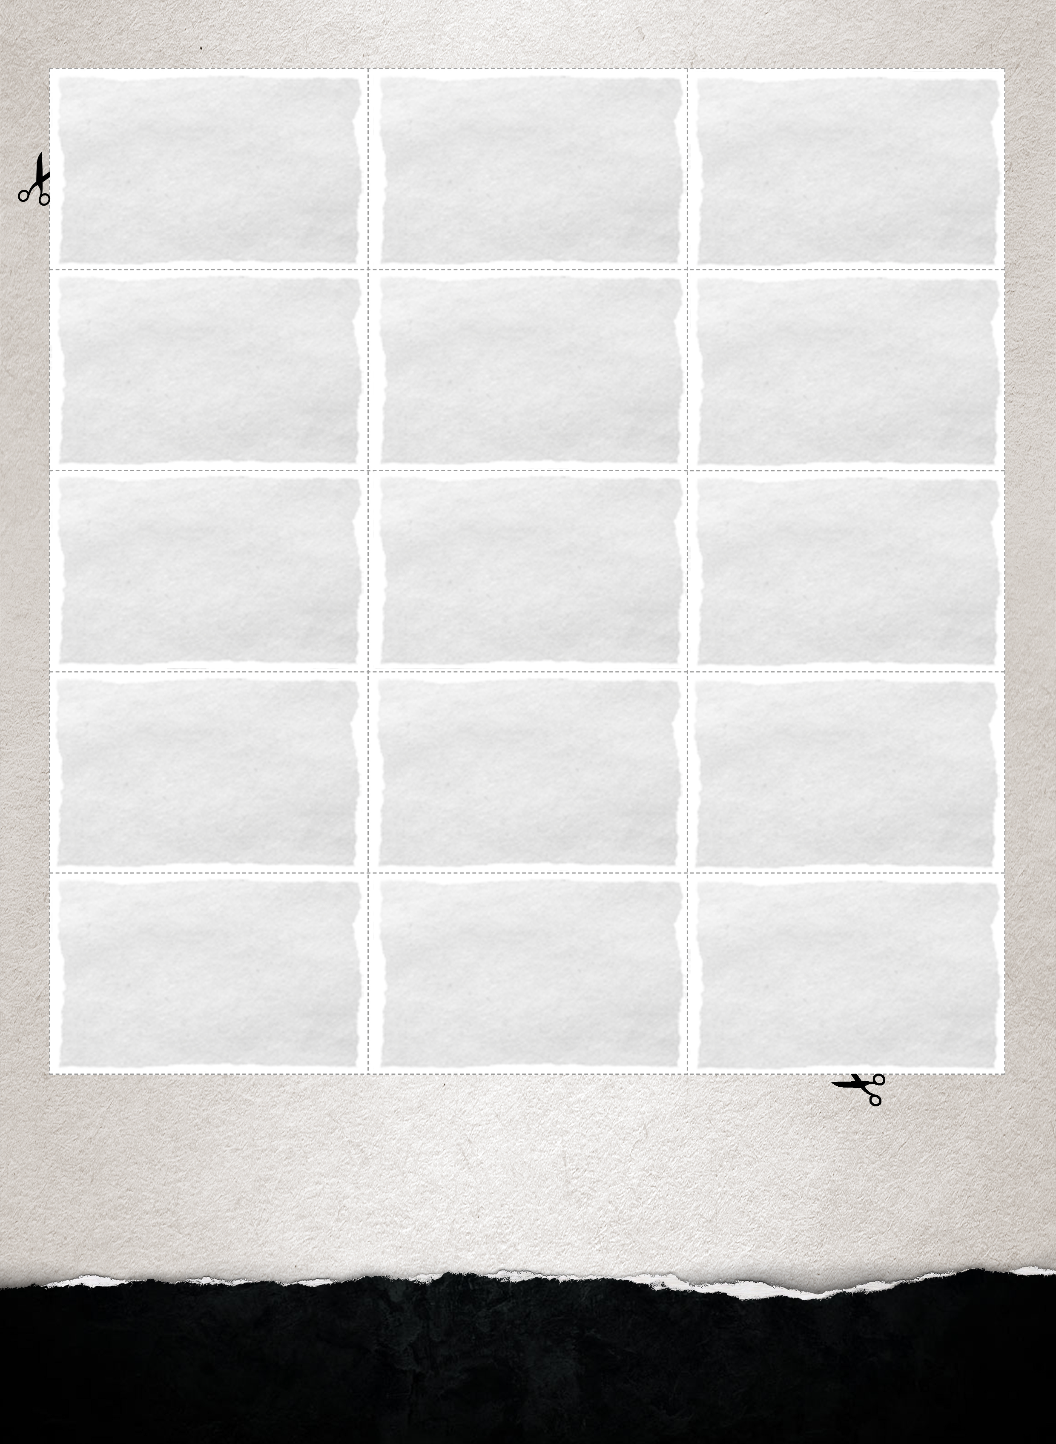

PUPIL WORKSHEET: The Great Fire of London

