Welcome to the Madame Tussauds London research team! The curators have an important item on today’s agenda: who deserves a place in Madame Tussauds?
BEFORE YOUR VISIT



Activity 1
For over 200 years, Marie Tussaud and the company who followed

her have been making likenesses of famous people, beginning with the French Royal family, and the noted American, Benjamin Franklin. In early 1800s, she first brought her trade to Britain.
She then toured with her wax figures for the rest of her life*.
Marie Tussaud herself is immortalised in wax at the attraction in
London today! The people included in the exhibition change over time.
- Recall a visit to any museum you have made before. What did it include? Why was it created? How do you think the curators chose the objects to include in that museum? Why would they change them?
- How would you arrange the exhibits in a museum?
- Now examine the front cover of the 1884 catalogue on the right to promote Madame Tussauds. What sorts of people would you have expected to find inside the exhibition as:
  - Exhibits?
  - Visitors?
- Which words on the catalogue support your answers?
- How does the image of the building housing Madame Tussauds add to the message of the catalogue?
Wherever you see a * visit the website to find some more insider facts!

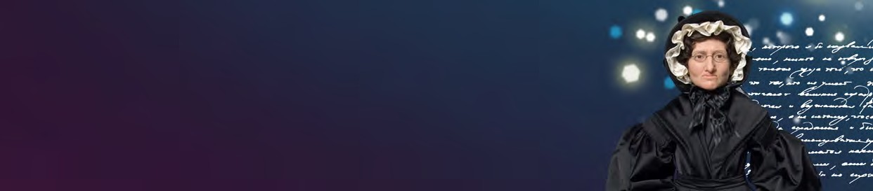
SECONDARY
KS3/4
HISTORY
STUDENT TASK SHEET
1

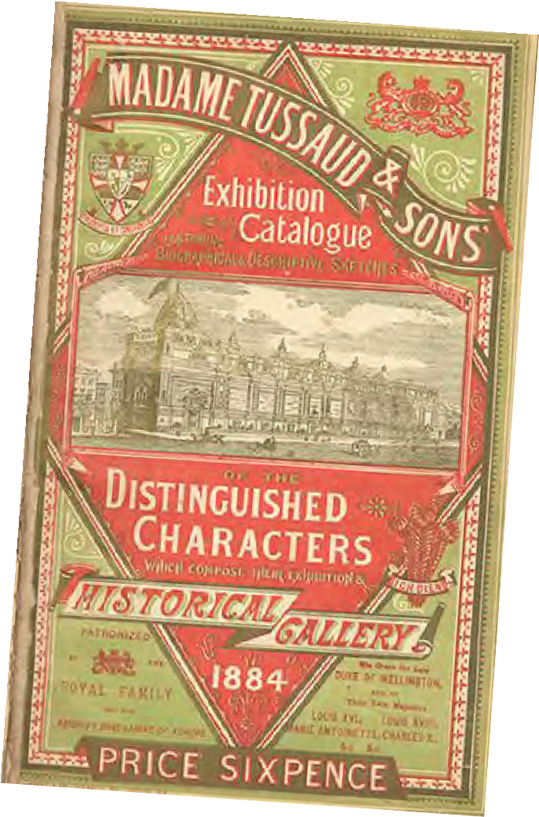Activity 2
Think back to the people and places you have studied in your recent work in History lessons.
- Pick three people from that work, who you think deserve a place in Madame Tussauds.
- Explain how you came to your decision, i.e. in a sentence or two explain what sets these three people apart from the rest of the people you have studied.
- Share your results in a group of three or with the person next to you. Have you chosen the same people? Do you agree that the choices of others are valid choices, even if you do not agree?
- In your group, select just two characters who you will put forward to the senior curators as being worthy of a place at Madame Tussauds. You will need a good reason for their inclusion.

Activity 3
At Madame Tussauds, the sculptors create the wax figures as though they were doing what
they are famous for. The same should be true of your figures.
- Create a list of what it is they have done or achieved that makes them worthy of their place in history.
- Agree in your group the most important item on your list.
- Write a description that gives a brief biography of the person and a more detailed narrative account of the key events.

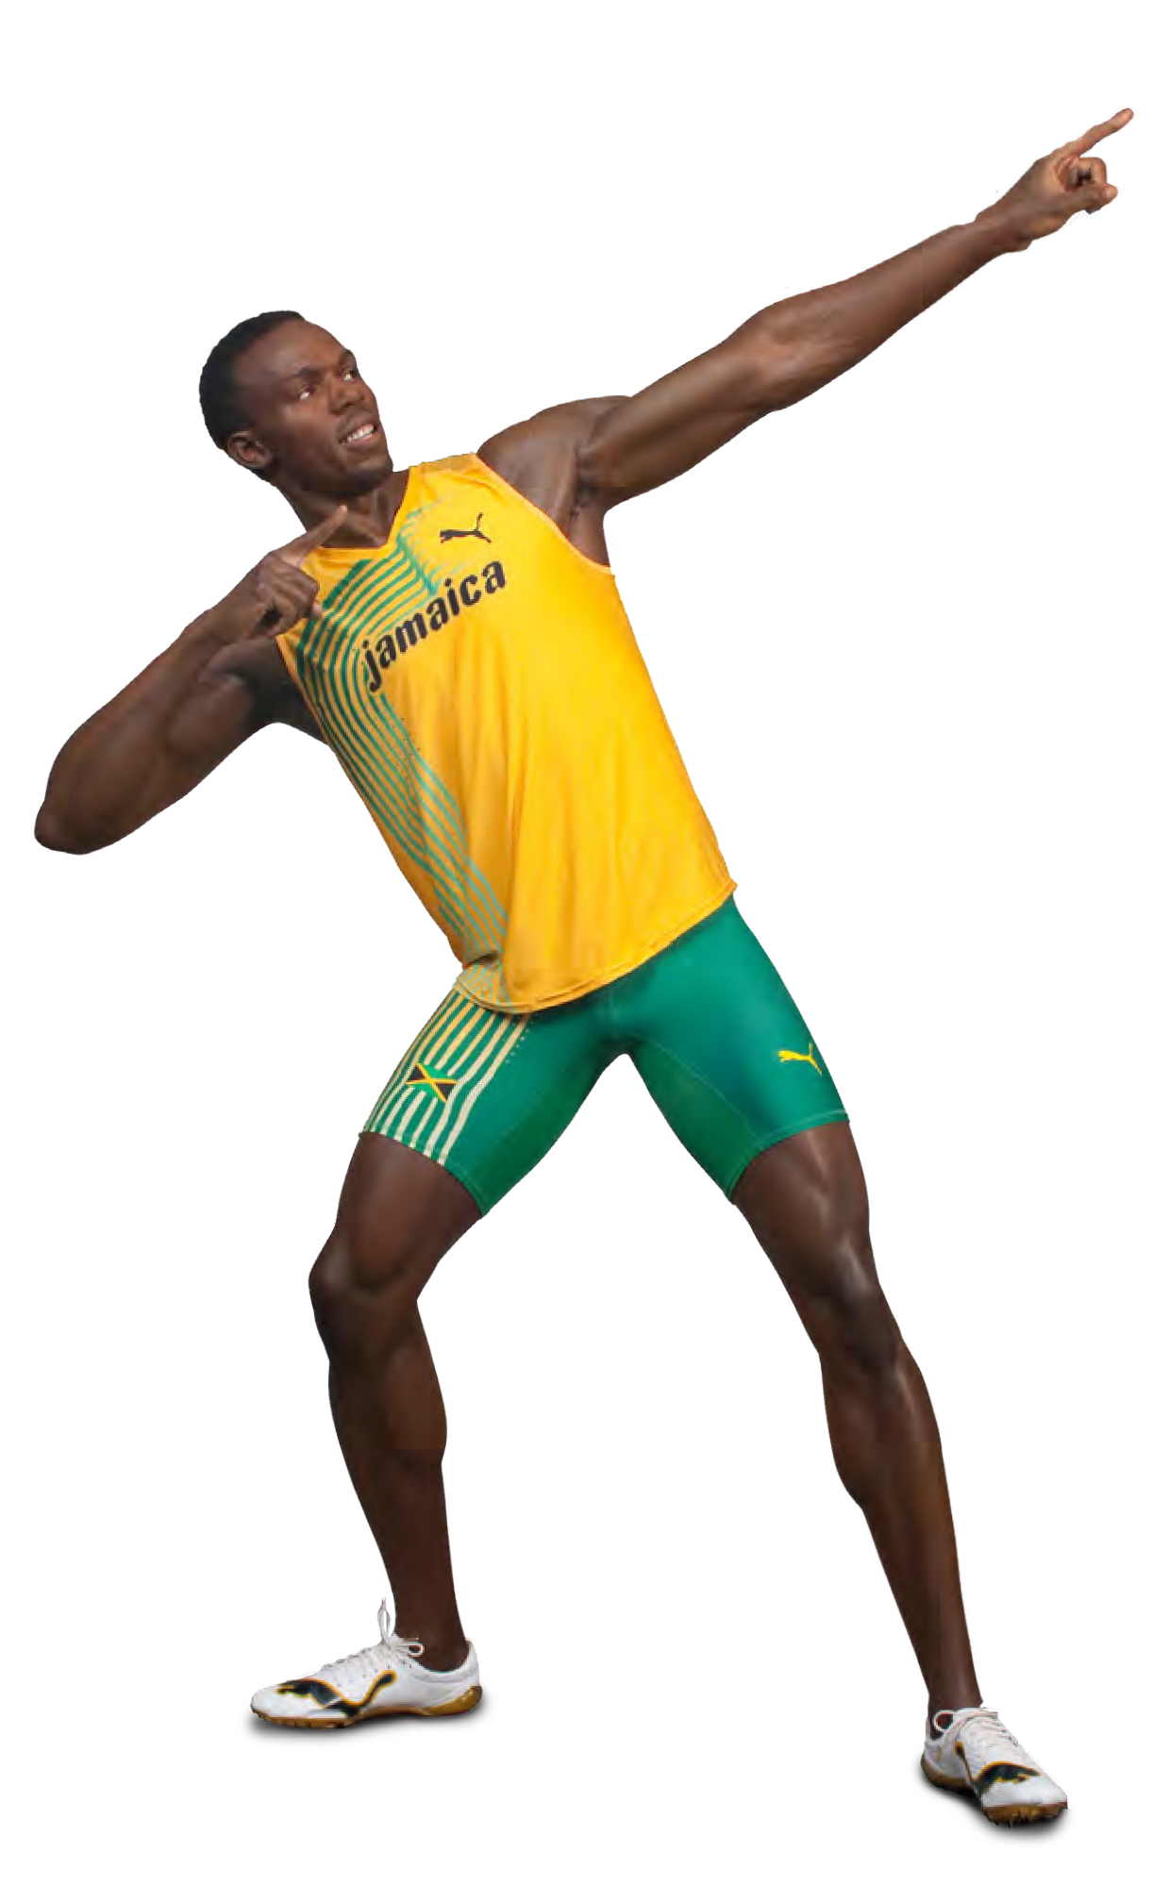Activity 4
You are going to draw the scene you described. First you need to do some thinking and research. What would the
setting be like? How can you find out what it might have looked like? Are there any contemporary descriptions or paintings they might help?
You will need to decide whether to show the cause or the consequence of the person’s importance.
- Carry out your research, making notes of which sources you have used.
- What would your main person be doing?
- Remember to include a statement which describes the person so that the pose becomes something that adds to the viewers understanding of who they are and why they are significant*.

Activity 5
A curator’s job isn’t finished when the sculpting is done. You have to consider where you will display your characters. Take some time to look at the figures all of your class has produced.
- Do any themes emerge from what you see (think back to the catalogue in Activity 1 and Empire, for example) or are there distinct types of people?
- You could use these themes as a way to organise the characters. Within the categories, how will you organise these people: date order or increasing significance or something else?

Activity 4 Hint:
You can use a number of different sources to inform your research – novels, paintings, text books,
news articles.

DURING YOUR VISIT



Activity 1
Your suggestions for a new figure have been accepted, and now it’s time to make a site visit to make sure the layout of your new set is in keeping with the rest of Madame Tussauds. It is helpful to begin by investigating the heritage of the attraction you see today. Find answers to the following:
- How did Marie Grosholtz begin her career?

- Why was the exhibition so popular in the 1800s?

- How did the public normally find out about prominent figures of the time?

- How was Marie Tussaud’s attraction different?*

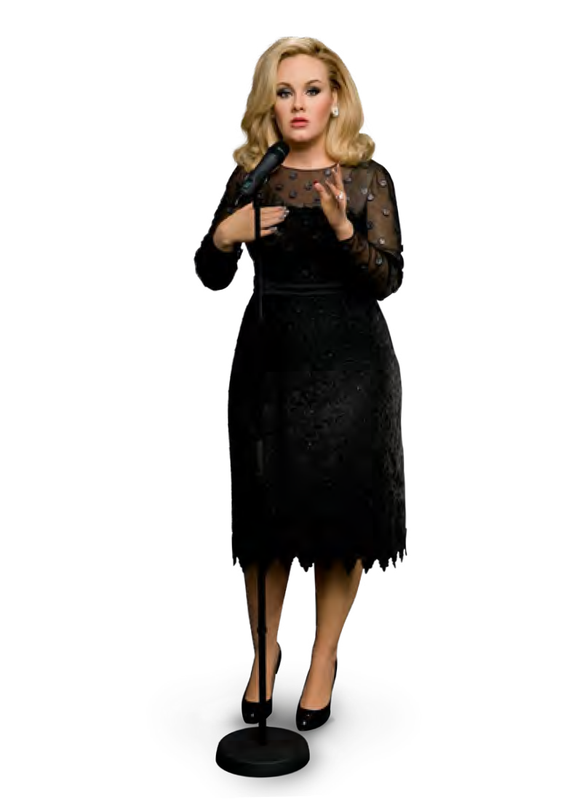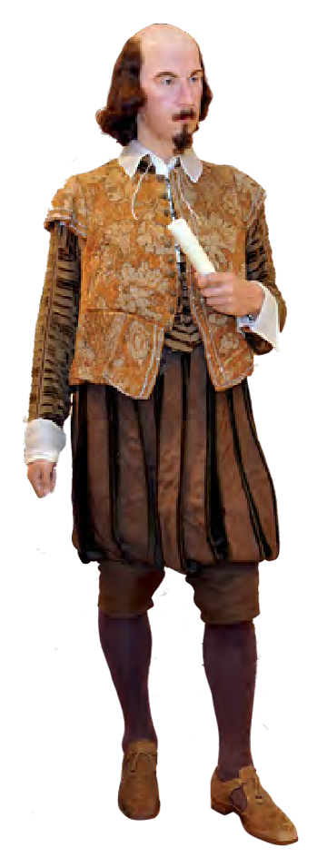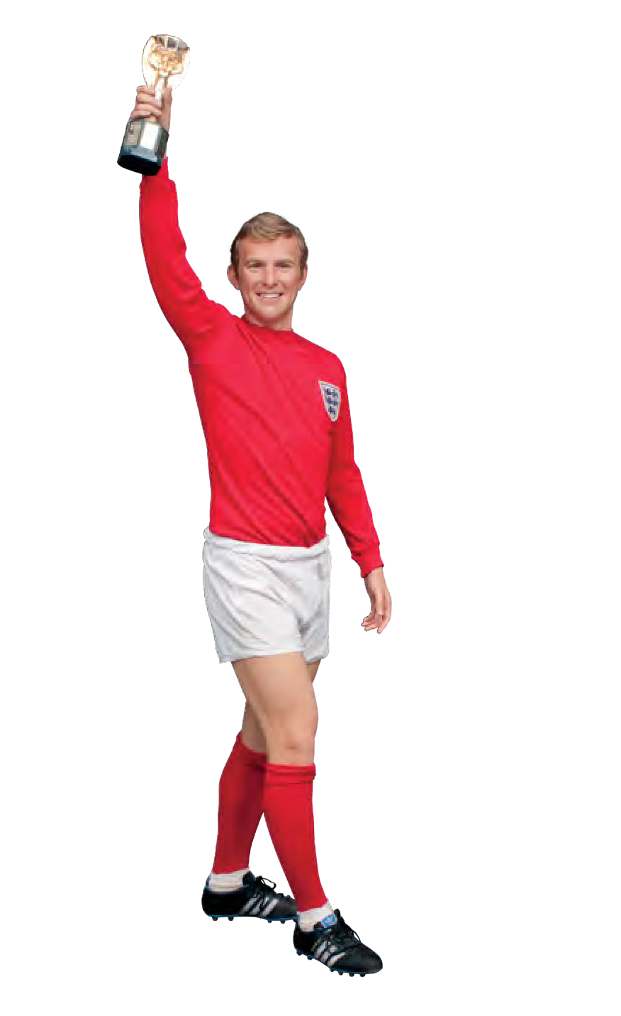

Activity 2
Whilst you are moving around the attraction, look at as many figures as possible and answer the following questions:
- What can I learn from the figure about this person?

- Can I tell what has made them significant?

- How have the curators made this interpretation possible?



Activity 3
Whilst you are exploring the different wax figures, you should find and record your observations of:
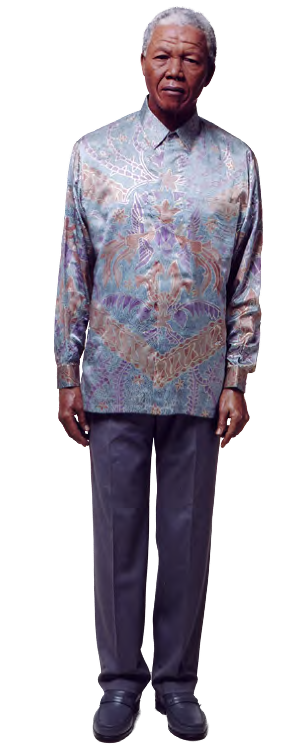a) A politician (e.g. Nelson Mandela)
b) A cultural icon (e.g. Victoria Beckham)
c) A member of the royal family.
d) How do their poses or expressions differ?

Activity 4
At Madame Tussauds, not only can you find out about people and the times they lived in but also about places. Make a visit to The Sherlock Holmes Experience and journey to Victorian London.
- What does the experience tell you about life in London at that time?

- What are its key features – what sets it apart from Britain’s countryside?

- Are there any clues about what the curators of the experience thought about Victorian Britain?

- Was it positive (good) or negative (bad)?

- What evidence do you have for your answer?

HISTORY

STUDENT TASK SHEET
SECONDARY
KS3/4

7

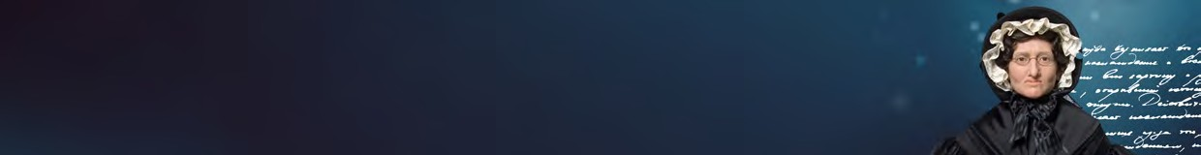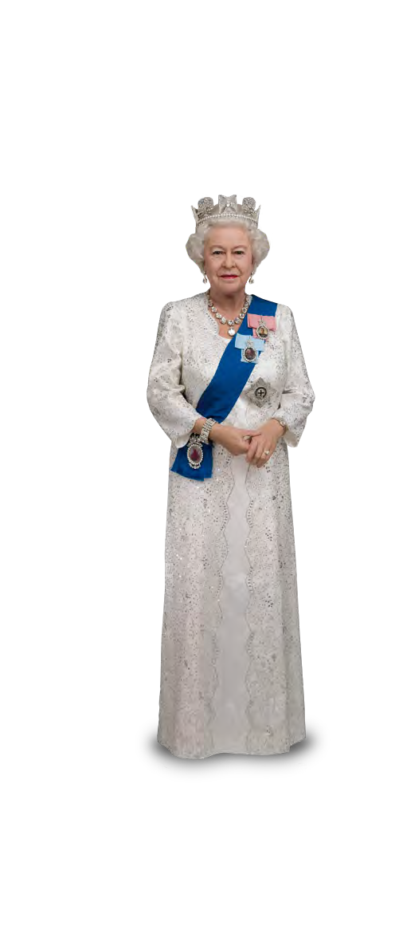

AFTER YOUR VISIT

Activity 1
Revisit the drawing you made for your figure before the visit. Now that you have seen the wax figures for yourself and their grouping and setting, evaluate your suggestions using the questions below.
- What would you change, having now been to Madame Tussauds?
  - Layout
  - Poses
- Explain why you would make these changes.

Activity 2
Your notes and photographs should reveal certain qualities about the famous people showcased at Madame Tussauds.
- Group together the different people you saw (for example world leaders) and discuss the facts you inferred from how they were presented.
- Make a list of:
  - Similarities of the figures within the categories
  - Differences of the figures within the categories
- Using the similarities about categories, can you describe
a ‘stereotypical’ version of a wax figure based on the work carried out at Madame Tussauds.
- Would any of the people you saw be worthy of a place in the attraction for all their lives (think about Nelson Mandela, for example)?

Activity 3
Using your work on The Sherlock Holmes Experience, conduct further research to answer the following questions:
- Sherlock Holmes is a key fictional detective, famous for (among other things) a deerstalker hat, a curly pipe and playing the violin*. Why is he such a well-read character?
Now imagine the conditions of Victorian London.
- How might they affect policing crime?
- Did Sherlock Holmes use the skills of the historian to apprehend wrong-doers?


SECONDARY
HISTORY
STUDENT TASK SHEET
KS3/4
8
AFTER YOUR VISIT

More Fun at Home
Sherlock Holmes used deductive reasoning – the notion that once you rule out the impossible, whatever is left, however improbable, must be the truth. This is similar to history, but not the same.
Using the pictures and sketches from Madame Tussauds, research one character or figure. The moment recorded in the Madame Tussauds is one of countless thousands.
Your challenge is to devise a different version based on other findings.

Activity 4
Time to investigate your findings further…
- How do you imagine the experience was created, 
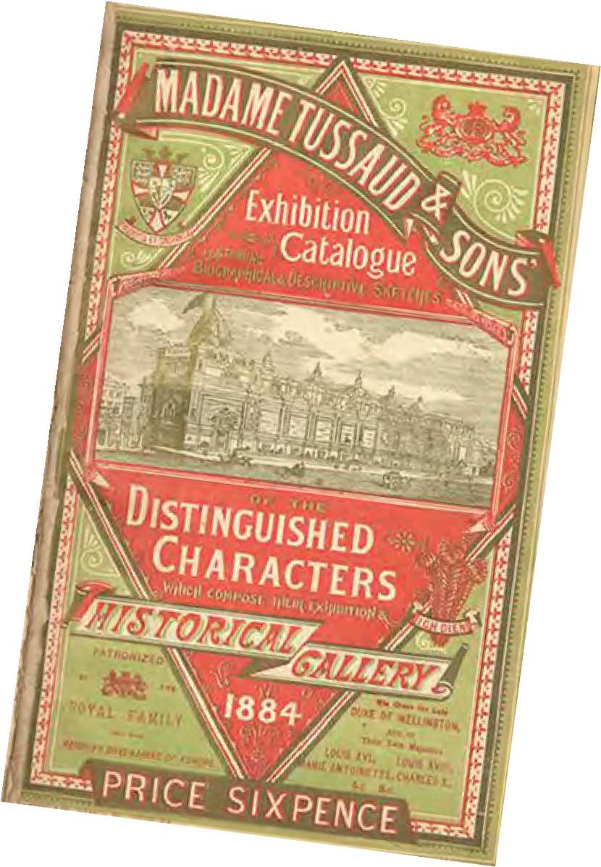i.e. what research was completed?
- How could you test the accuracy of the interpretation of Sherlock Holmes?
- Do you think it is a complete version of how London or how Britain was? What would you add?

Activity 5
Thinking back to the 1884 catalogue cover and having now visited Madame Tussauds, you have been asked to design a new cover for the catalogue. This should:
- Inform and attract visitors
- Include relevant signs distinctive of the time
- Replace the label ‘historical gallery’
- Reference to Sherlock Holmes

