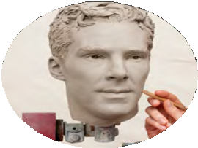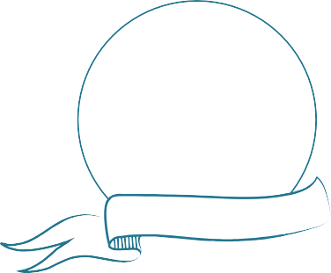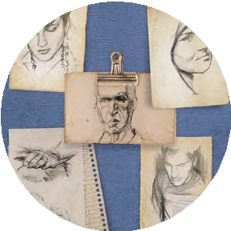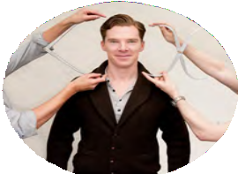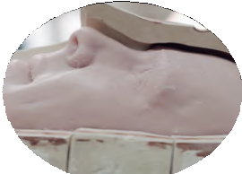
SECONDARY
KS3/4
DESIGN TECHNOLOGY
STUDENT TASK SHEET
1
Decide which famous figure would make an inspiring addition…
r

To create an accurate wax figure, sculptors need to… so that….
This helps to…
3. n

Why does the sculptor create a clay model of…
Pl

It’s time for you to join the design team at Madame Tussauds London and take a look behind the scenes…
BEFORE YOUR VISIT

Activity 1
Every wax figure you will see at Madame Tussauds is made in the same way and uses the same process from start to finish. The images show a step by step guide to the process.
- Can you explain what is happening in each of the pictures below?
- Give detail of the tasks and information you would need to successfully complete each part of the process.

DESIGN TECHNOLOGY

STUDENT TASK SHEET 2
SECONDARY
KS3/4

BEFORE YOUR VISIT

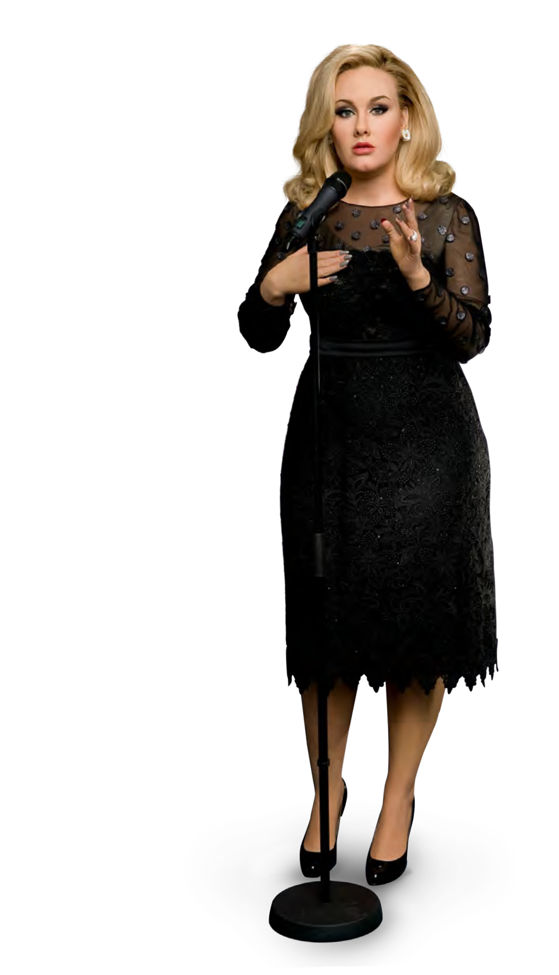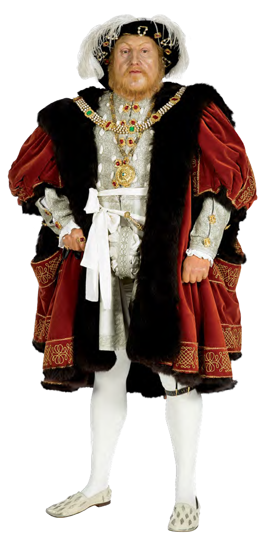

Activity 2
As you have seen in Activity 1, research and planning are very important to Madame Tussauds. Making a wax figure is an expensive process*,
so it is important that visitors will be
interested in meeting the figure and that the person will be famous for some time.
As part of your new role in the design team at Madame Tussauds you have been asked you to research, plan and market a new wax figure or group of wax figures for the attraction, that will specifically appeal to somebody of your age group.
- Design a short questionnaire of 5-10 questions which you will use to survey your classmates on which famous figures they are most interested in and why.
- Conduct your survey. You should speak to at least five of your classmates to make sure you have a large enough set of results.

Activity 3
An important part of creating a new figure is choosing the clothing.
At Madame Tussauds, it is a tradition that the famous person who has had a wax figure made of them donates his or her own clothes to make it more authentic*. When this is not possible
(for example, when it is a historical figure like Henry VIII) the costumes will have to be made.
- To get inspiration for your new figure, do some research and create a mood board of ideas which could include the following images:
  - Famous figures you may like to focus on or look at on a visit to Madame Tussauds
  - Colours
  - Textures
  - Fabrics
  - Clothing shapes and styles



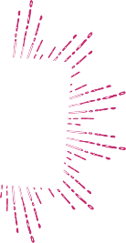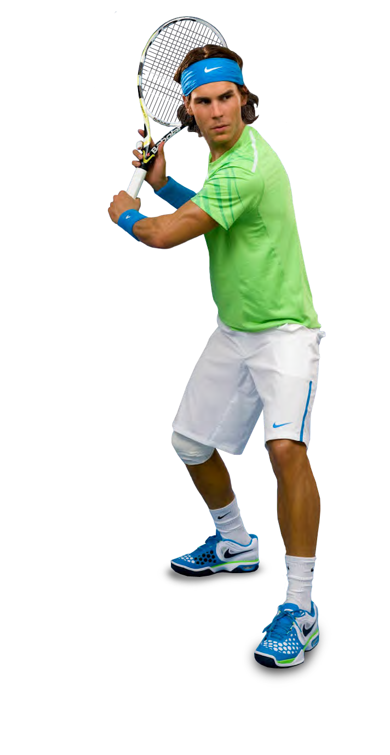
DURING YOUR VISIT

Activity 1
As a designer, it is your job to understand the detail of a new figure. Take a look at the Behind the Scenes area at Madame Tussauds and consider the following:
a) Create a fact file… Consider some of the questions below*: How much does it cost to make a figure?

Why do you think it is this much?

How long does it take to make a figure, from start to finish?

How many people does is take to make one figure?

Can you name each of their job roles?

How many measurements and photographs are taken at the celebrity sitting?

Activity 2
Expand your research and take note of the most popular category of figures at the attraction as you are walking around.
- Write them down here. Include as much information about them as possible, for example what can you understand about their personality from the figure?

- How are these personality traits displayed? Do they match with the type of famous figures you identified in your market research from Before your visit, Activity 2?

Activity 3
A high street fashion store also wants you to create a value version of the outfit worn by your new figure. During your visit you will need practise profiling the costumes on display.
- Get up close and profile a wax figure, making notes on their costumes. This will help guide you on the detail required for your new figure.

- Fill in the table below giving examples of the details you would alter of the design and the cheaper alternatives you would use – remember that your version needs to be mass produced.

Design feature | Possible alternative

- You may want to take pictures to remember how things look or are made as inspiration for your design.

AFTER YOUR VISIT

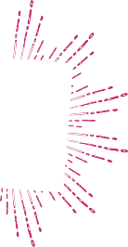

Activity 1
As part of the planning for your final figure you will need to understand what they are made from as well as how they are made and what they wear. Madame Tussauds sculptors use materials that are carefully chosen for their properties.
- Identify some of the main properties of the materials in the table below:

Material | Properties
Wax
Metal
Clay
Glass
Sponge
Plaster
Wood

- Which of these materials would be useful to make a figure for Madame Tussauds*?
For example, would an exhibit look realistic if a figure’s face was made from sponge or wood?

Material | Component | Why?

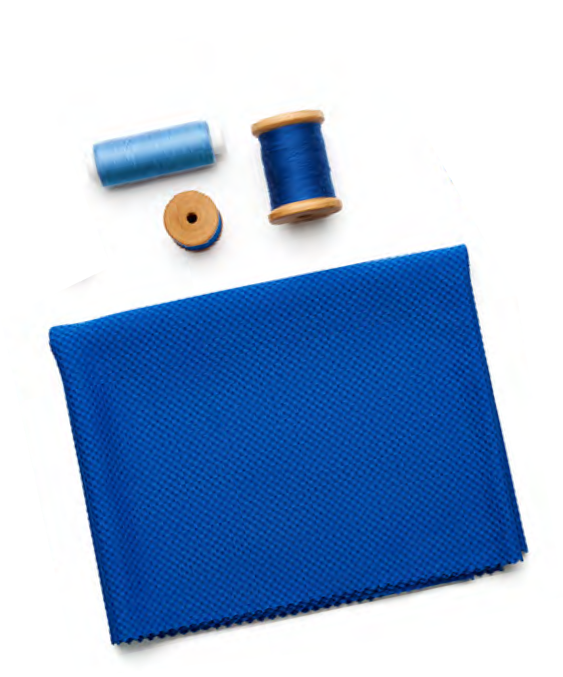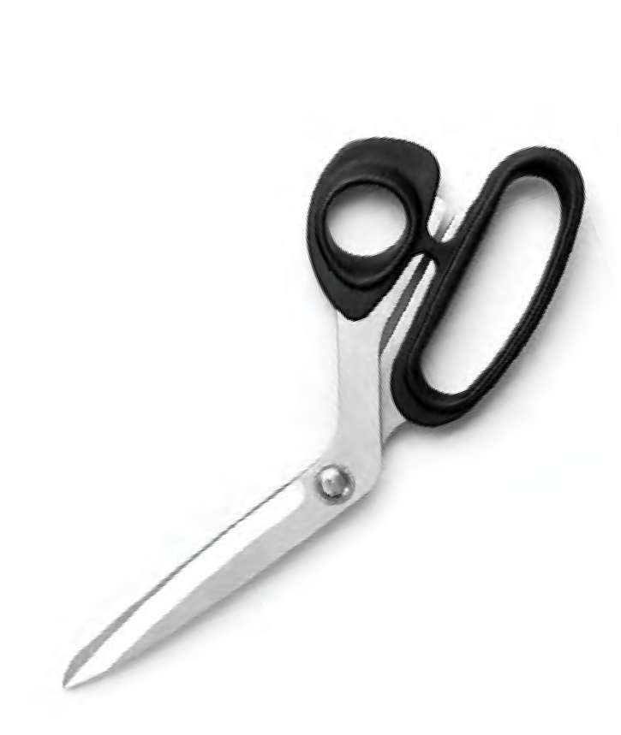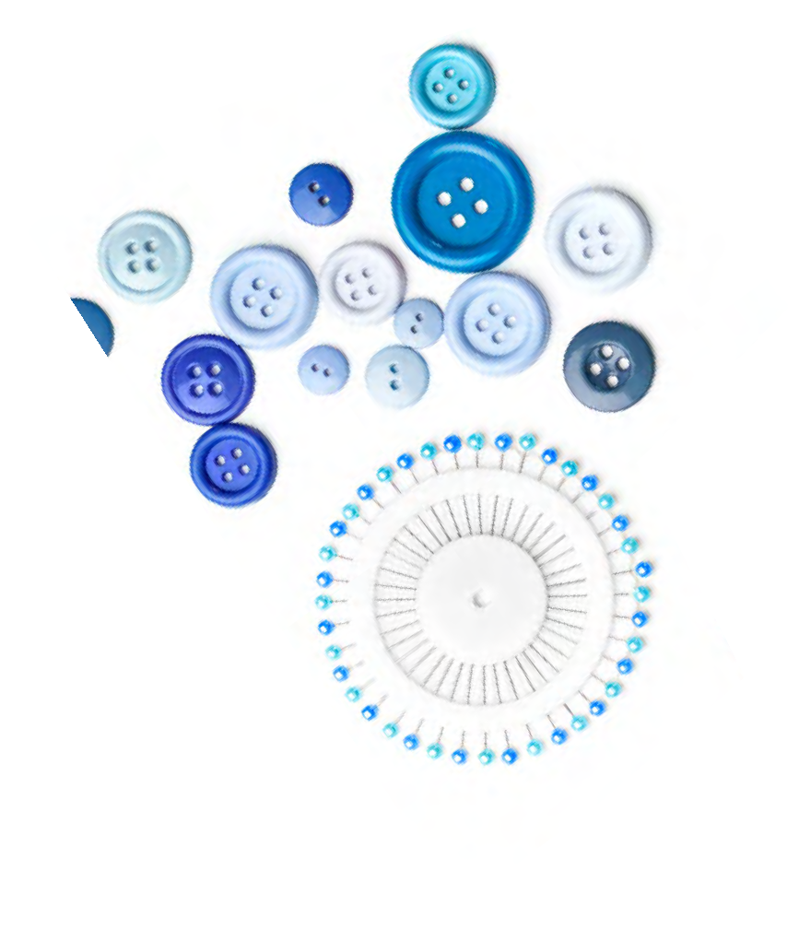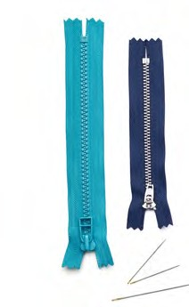

Activity 2
You are now going to produce the value version outfit for the high street fashion store, don’t forget to use the research you conducted in class and your investigation at Madame Tussauds into the costume of the famous figures.
- Choose the materials you are going to make the piece of clothing from. Consider which materials will make a good copy of the famous figure’s outfit without being too expensive.
- Draw out a pattern for your item of clothing. Patterns are paper templates you pin to fabric and cut round. Make sure a seam allowance is included.

- Before you begin making your product, think about the following:
  - Make sure that you have the right materials and equipment
  - Make sure you know how to use the equipment safely and that you have the skills to do so.
  - Think about the techniques you will use for your task
(i.e. What kind of stitching will you use? Will you use darts? What kind of seams will you use?)
  - Think about health and safety – is your workspace clear?
Hint:
Make sure you look at these as you are working so you know how to do well and succeed!

- When you are finished, ask a friend to evaluate your work out of ten using the success criteria below.
  - Did you make the right choice of materials?
  - Could the method you used be improved?
  - Which aspects of the process were you pleased with?
  - Does the product work/look good?
  - Could it be improved?
  - How accurate were you?

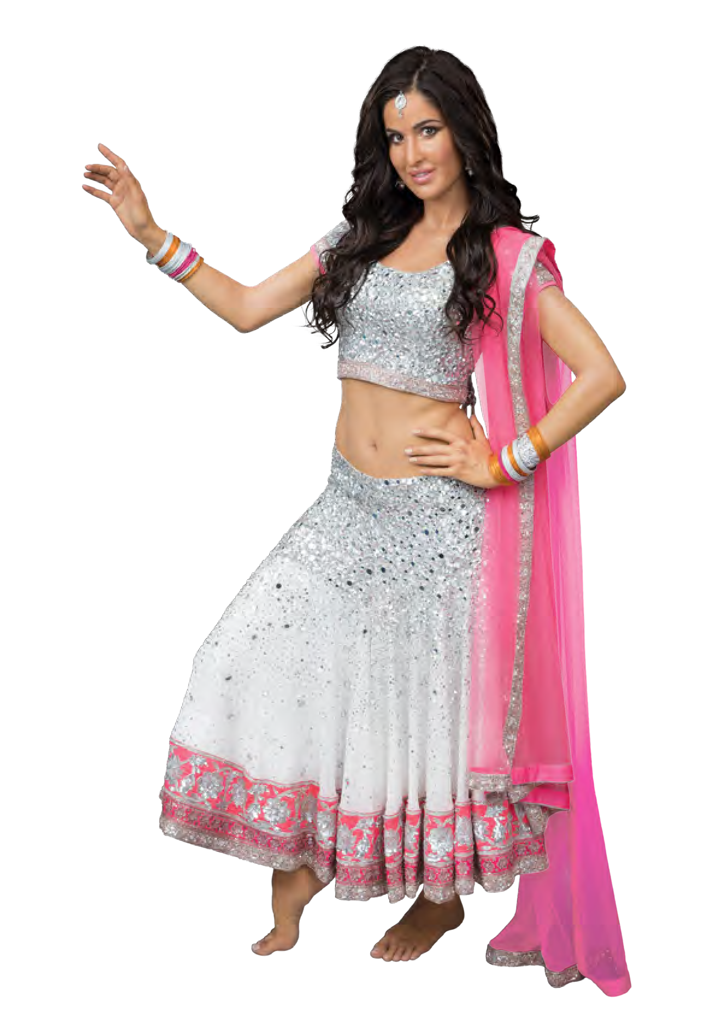


Activity 3

You have been asked to create a poster to be displayed around London, advertising Madame Tussauds and the new wax figure you have researched. However, there’s a catch! The poster cannot reveal who the new celebrity is as it will be a surprise launch to capture the attention of future visitors and create excitement*!


- Create your poster showcasing your secret celebrity (this will also be posted on the Madame Tuassuds website). You can give clues about promoting the secret celebrity such as:
  - What does the celebrity do?
  - Do they have a specialist career or skill?
  - Without giving away their name or face, how are they recognisable?
  - Where do they appear?
  - What things do they like?
  - What are they most famous for?

More Fun at Home
Your excellent work on recreating the celebrity costume for
the high street fashion store and supporting marketing materials for the grand opening of the new figure have been noticed by the General Manager of Madame Tussauds!
They would like to offer you a permanent job at the attraction, but first you need to present your work to their team.
You can be as creative as you like!
Your presentation should include:
- Images of props or objects associated with the figure you have chosen
- Rough outlines sketches of the set
- Suggestion of the materials and colours you would use to theme your set

Hint:
If your memory needs refreshing of the famous figures exhibited at Madame Tussauds, you should visit the Madame Tussauds website
at www.madametussauds.co.uk to remind yourself!

