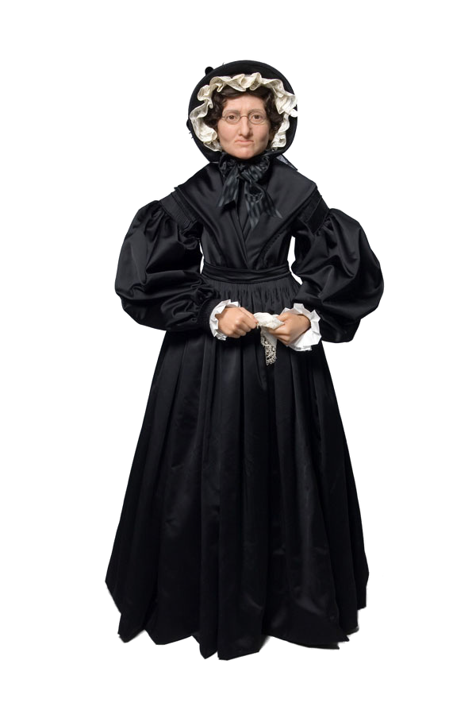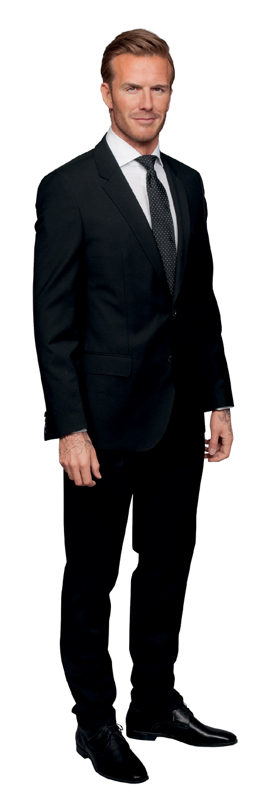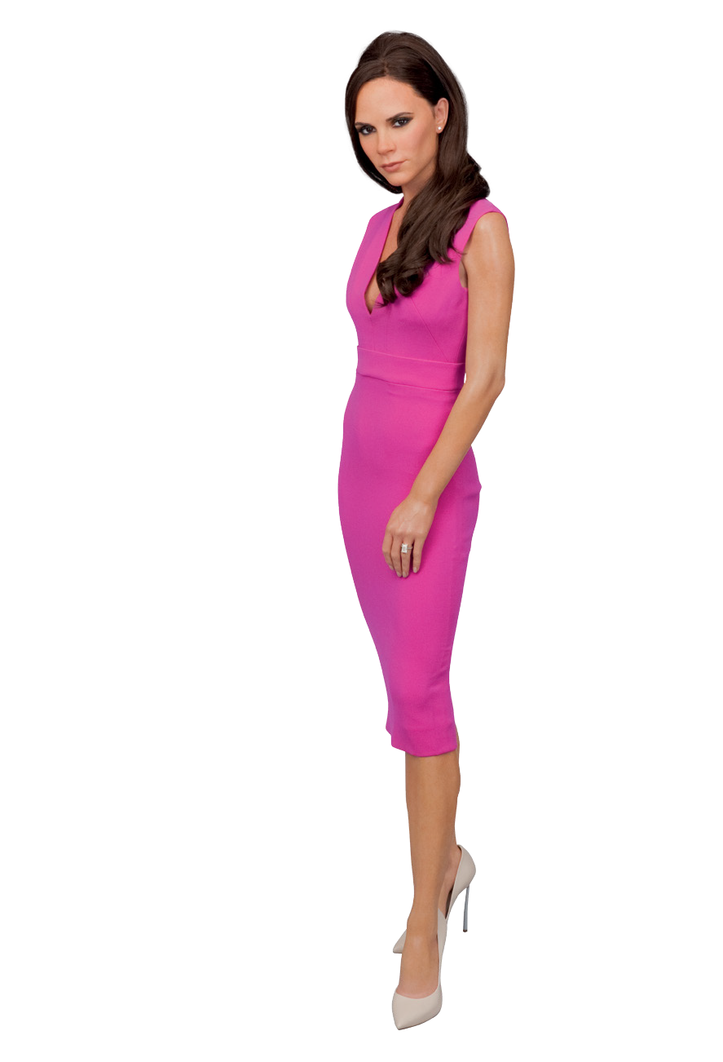
SECONDARY
KS4/5
BUSINESS STUDIES
STUDENT TASK SHEET
1
Activity 1 – Entrepreneurs
a) What do Marie Tussaud, Beyoncé and Alfie Deyes have in common?
b) What is unique about the success of these individuals?
BEFORE YOUR VISIT

- How have environmental/historical factors impacted on their success?

In pairs, think about what is meant by the term ‘entrepreneur’.

- How do you think this term relates to being successful in business? Write down your thoughts and ideas.

- Carry out internet research into Marie Tussaud*, Beyoncé and Alfie Deyes.


Make sure you include information about the following:


  - The businesses they have set up and the products or services sold.
  - How successful these businesses have been and why?
  - Find and print out a recent article about these entrepreneurs.

Wherever you see a visit the website to find some more insider facts!





l
l

- Using the research you have carried out, define the qualities and characteristics of a successful entrepreneur. Look at the articles you found about Beyoncé and Alfie Deyes – how do you think they used their fame and the media to help their businesses?

- Comparing the two entrepreneurs, do you think that it is easier to be an entrepreneur now than in the 18th century? Give justified reasons for your answer.

Activity 2 – Business Culture, Objectives and Strategy
- Read through the information below about Merlin Entertainments.

Merlin Entertainments is the largest entertainments company operating in Europe. Merlin runs over 100 attractions in 22 countries, across four continents. It is their aim to deliver unique, memorable experiences to millions of visitors across their growing estate.
OUR PASSION
We are first and foremost an entertainment company. Our passion is putting smiles (or screams) on people’s faces and giving our customers memorable experiences. Through creativity and a relentless drive for excellence we aim
to immerse our visitors in our brands, constantly delighting them and enriching their understanding through fun learning. In simple terms, we love what we do!
OUR VISION
Our vision is to become the worldwide leader in branded, location-based, family entertainment.
OUR STRATEGY
Our strategy is to create a high growth, high return, family entertainment company based on strong bands and a portfolio that is naturally balanced against the impact of external factors.

- Discuss in pairs the difference between the Merlin Entertainments’ Mission Statement (OUR PASSION) and their Vision Statement (OUR VISION). Note down the differences below.

l
l

- Using your knowledge of strategic planning, discuss in a group and explain below the importance of business planning and how this links to business growth,

Hint:
Use the information included on the Merlin website www.merlinentertainments.biz/ strategy
using Merlin Entertainments Strategy as an example.

- Suggest a method by which Madame Tussauds could extend its business model, and thereby increase its revenue. For example, could Madame Tussauds extend its method, product or services beyond entertainment?

DURING YOUR VISIT

Activity 1 – Research
Madame Tussauds is a wax work attraction that has evolved over the 250 years of its existence.
As you go around the attraction this checklist is designed to help you note some of the key aspects of the attraction and gain further insight into the Madame Tussauds case study.
Checklist Questions
  - Where is Madame Tussauds located?

  - Over how many floors and rooms are the wax figures located?

  - How many times did you see a Madame Tussauds host?

  - What were the hosts’ roles? Were they helping to make the visitors’ experiences better?

  - How many of the areas relate to current film or television tie-ins?

Checklist Questions
6. As you go through the Behind the Scenes* area make notes and complete the following: Process:

The Sitting:

Sculpting:

Moulding:

Finishing:

- What area do you enjoy the most and why?

- Are there improvements that you would like to see made to Madame Tussauds?

- Are there any other wax figures you would like Madame Tussauds to display?

Activity 2 – Market Segmentation
For each of the market segments below write down the needs of each group and how Madame Tussauds caters to their needs.

 Overseas visitors
SECONDARY
BUSINESS STUDIES
STUDENT TASK SHEET
KS4/5
8
DURING YOUR VISIT
guests
Schools Corporate

Families

Activity 3 – Market Segmentation
In Madame Tussauds the celebrity wax figures are placed into different areas. Mark down the names of these areas on your visit. Using the areas as headings below write down the names of some of the celebrities in each area and which target group would be most interested in this area.
Celebrities:
Target Audience:
Celebrities:
Target Audience:
Celebrities:
Target Audience:


Celebrities:
Target Audience:
Celebrities:
Target Audience:
Celebrities:
Target Audience:

SECONDARY
BUSINESS STUDIES
STUDENT TASK SHEET
KS4/5
10
DURING YOUR VISIT
l
l

Having carried out your research and completed the table above, are there any other products or services that Madame Tussauds could offer the different groups above? How realistic do you think your suggestions are?

AFTER YOUR VISIT

Activity 1 – Branding
A brand name is a name given to a product or service to differentiate it from other products provided from the same business, and also from the business’ competitors. Within Madame Tussauds some of the major exhibitions are branded so they can be easily identified by visitors. Madame Tussauds can also use these brand names in their promotional activities. Businesses like Madame Tussauds spend a large amount of time and resource on promoting their brands. The more the brand is promoted the more well-known it becomes.
- 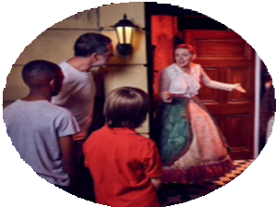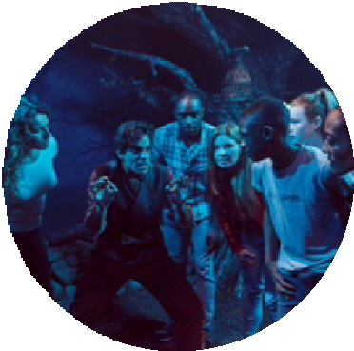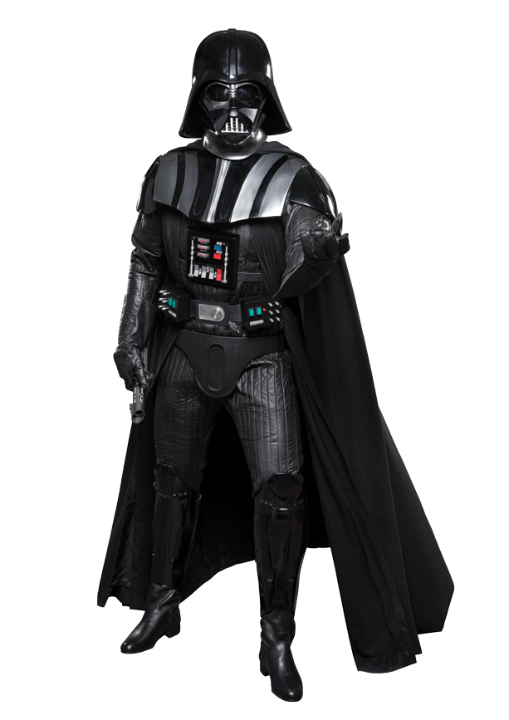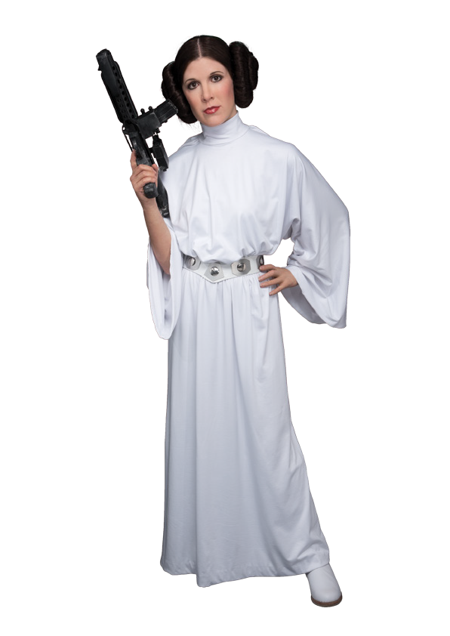Research brand names featured at Madame Tussauds. Look at the images and write a short description of each of these brands, providing suggestions as to which target group would be most interested in these parts of the attraction.

Marvel

Sherlock Holmes Experience


Star Wars*


SECONDARY
BUSINESS STUDIES
STUDENT TASK SHEET
KS4/5
11



- Can you develop a new brand name and attraction for Madame Tussauds?
Design a logo for this brand name – you should use this as a means of attracting visitors.

- Write promotional material for the new brand – think about how your use of language can create anticipation and suspense. You really want people to visit and enjoy the attraction!
- Explain what target group you are aiming this particular attraction at.

- Explain your reasoning behind developing the new brand name and attraction.
How could you justify that your ideas should be taken on board and turned into reality?

Activity 2 – Customer Service
An organisation is only as good as the people who work for it.

In an organisation such as Madame Tussauds it is the front line staff, the hosts, security guards and actors, who represent Madame Tussauds.
Madame Tussauds encourages all staff members to consider the following points when dealing with customers:

Warm welcome – the key to a successful attraction.
1

2

3

First impressions – are lasting and our visitors will remember the impression you give.

Stars of the show – You are part of the show, your presence can bring the attraction alive.

Appearances count – You are on show, look the part to meet our visitors.
4

Excuse me? – Know the attraction and be ready to answer questions.
5

6

7

Fun, fun, fun – You are in the entertainment business, show you enjoy your work.

Be prepared – For unexpected emergencies and know how to handle any situation.

Positive thinking – take the initiative, make suggestions to make your attraction even better.
8

Litter – Is everyone’s problem, so take pride in your site.
9

10

Winning team – work together and use your talents to the best.


l
l
a) Complete the diagram below detailing the effects of good customer service.

Effective customer service encourages...

- Why does Madame Tussauds need to rely on the initiative and dedication of its staff?

- Give some examples of how a dedicated host could make a difference to a visitor’s experience.

Activity 3 – Customer Service
Staff at Madame Tussauds are taught to deal with face-to-face customer complaints by using the following behaviours:
Stay calm.
Empathise/ sympathise with the customer.
Make sure any further
communication is as agreed with the
guest.
Use an area where the staff and the guest feel comfortable to deal with the complaint.
Try to find out what can
be done to make the guest feel better and act on it.
Listen – be patient and pay attention.
Don’t justify
– offer solutions, not explanations.
Use positive body language.
Be aware of when to call for assistance.

- Use the guidelines above to help you to decide what should be done in each of the scenarios below:
A customer who can’t speak English is trying to find out where the toilets are located.
A customer complaining that they had to wait too long in the queue and it has effected the rest of their day.
A customer complains to you that another member of staff was rude to them.
A group of customers loudly complain that their favourite celebrity isn’t at the attraction. They came especially to see that particular wax figure because they thought they had read somewhere that it was supposed to be on show.
A customer complains that the Sherlock Holmes Experience was too scary for their young child.


l
l
- A visitor to Madame Tussauds has written the following feedback at the end of their visit.

I’m not sure that I enjoyed my visit. I got see the wax figures but I really thought that you would have wax figures of business people such as Bill Gates, Mark Zuckerberg or even J. K. Rowling.
I tried to speak to some of your people about it and they acted like I was annoying them.
I can’t say that I had the best experience.

What should Madame Tussauds do now?

- Write an email to this customer to address the issues they have raised and apologising to them that they did not have the best experience. What could you suggest or give them in order to make them change their mind about Madame Tussauds?

It is a well-known fact that an unhappy customer will tell ten times more people about a poor service they received, than a happy customer.
- What actions might an unhappy customer take to tell others about the poor service they received?

- How can these actions impact upon the organisation in question?

- How can an organisation remedy the situation as quickly as possible?

Activity 4 – Recruitment and selection
Take a look at the following website www.merlincareers.com/join-the-fun

In reviewing the website and the possible positions available you should realise that there a number of people who work for Madame Tussauds. As a visitor you may not have even considered how important they are to the successful running of the business. You have decided that you would like to apply for a possible position at Madame Tussauds as an actor. This is a ‘Front of House’ position. See the authentic job description below:


We are Madame Tussauds London and we are part of the Magical Merlin Entertainments!

We are currently recruiting actresses for a new and exciting adventure – Sherlock Holmes: The Experience.
Sherlock Holmes: The Experience is a daytime show which will be open to Madame Tussauds visitors. Groups will enter the fast paced experience and be guided through their own unique adventure. For this experience we are looking for the following roles:
Actor
Character actors with ability to play three to four roles, the roles require switching between 3 characters every performance. The ability to be a versatile actor is vital. Each performance will be performed in repetition, delivered directly to an audience, therefore an actor is required who is comfortable dealing with the public in a very close setting and relaxed with improvisation.
Essential skills and experience:
- Team player
- Previous immersive experience
- Ability to work in a close knit company
- Ability to play comedic roles
- Playing age 20-50

Please ensure you attach the following to your application; Actors CV, brief covering letter and headshot.

- Follow the instructions – draft a CV and covering letter that you think highlights your skills and abilities. Think carefully about what you would need to include so that you at least get called for an interview.
- Having now applied for this position, review the vacancies and apply for a second position.

- Re-write your covering letter so that it is more closely tailored to this new position.

Activity 5 – Financial Data
- Complete the Balance Sheet below.
The notation of individual balance sheets will vary but all must carry the same essential information.
- Fill in the definitions of the terms below.

MERLIN ENTERTAINMENTS BALANCE SHEET
Balance Sheet as at:

 | £m | £m
Non-current assets
Of which intangible assets
Current Assets
Total Assets
Non- current liabilities
Current liabilities
Total liabilities
Net assets
Total equity
Current Assets:
Current Liabilities:
The value of Net Assets can be found by:

- This balance sheet has Total Equity as opposed to RETAINED PROFIT.
On which other document would the Total Equity or RETAINED PROFIT figure be found?

l
l

- Having reviewed Merlin Entertainments’ financial data, what is the current financial position of the business?
- Does the business have the financial resources to carry out its strategic plans?

- Suggest some factors that may affect the future revenues and cash flows of Merlin Entertainments. Give justified reasons for your answers.



More Fun at Home
You’ve been tasked to create a homepage for your new attraction on the Madame Tussauds London website using your new branding and logo. Create a mock-up of the homepage persuading people to visit – be sure to use all your considerations from the previous activities!

Hint:
Visit the existing Madame Tussauds website to help you with the layout.

