

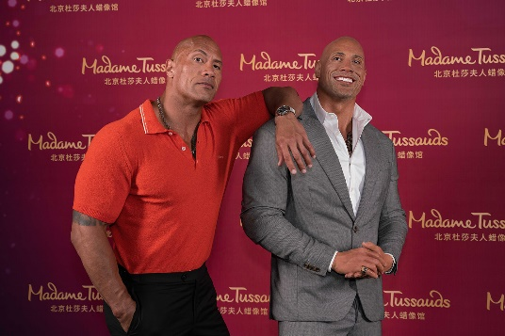
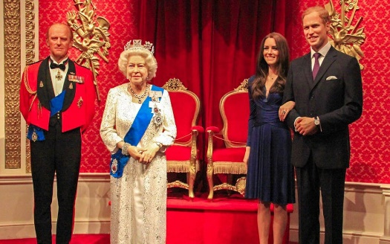
www.madametussauds.com/london
Work through the activities sheets and answer all the questions including the ones before and during your visit ones.
Have a read of “did you Know” facts and find out how long it takes to make a wax work.
Who would you like to see at Madame Tussauds ?

Walk down the red carpet and strike a pose with Benedict Cumberbatch and Kate Winslet, before exploring the sports zone with Usain Bolt and David Beckham.
Enjoy a once-in-a-lifetime audience with the royal family, including the Queen and the Duke and Duchess of Cambridge, before stepping on stage with music icons, from Madonna to Ed Sheeran!

Next, step up to your favourite Marvel Superheroes and immerse yourself in the Marvel Superheroes 4D movie, before meeting heroes and villains from Star Wars movies.
You'll also get a behind-the-scenes look at how sculptors create the figures, and a fun ride through the history of London in an iconic black cab.

Madame Tussauds

