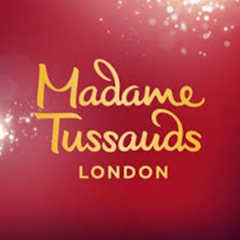
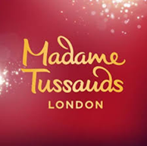
Did You Know!
Madam Tussauds.
* Hair insertion and styling a wax figure takes 140 hours. It also takes 15 hours to make a pair of eyes and 30 hours to make a set of teeth!
* Sculpting a figure take around 350 hours – that’s two weeks of nonstop work!
* A special mixture of beeswax and Japan wax is used to make the wax figures.
* As well as creating a successful tourist attraction, Marie pioneered the use of printed guides for exhibitions. The first edition of the Madame Tussauds Guidebook was printed in 1819.
* Marie Tussaud personally took the death masks of Louis XVI and Marie-Antoinette.
* 250 precise measurements of the head and body are taken to give Madame Tussauds’ sculptors. This information is crucial to accurately creating a wax figure.
* A sitting for a Madame Tussauds figure takes 3 hours!
* Charles Dickens was such a Madame Tussauds enthusiast he wrote essays about Madame Tussauds in his magazines. He would visit regularly and write reviews about the latest additions of wax models for newspapers.
*To create the head of a figure, wax is heated to 74 degrees Celsius and is poured into the head mould. The wax cools inside the mould and then the plaster sections are removed to reveal a hollow wax head.

* Each strand of hair is inserted individually by hand, using a forked needle. To complete a head of hair, this takes approximately five weeks.
* Creating a wax figure at Madame Tussauds costs around £150,000.
* Marie Tussaud bought the original robes worn by George IV during his coronation in 1821.
* A wax head weighs as much as an actual head, approximately 4-5kg, and 2kg of wax is used for a pair of hands. The typical weight of a whole figure is 25kg.
* Queen Victoria visited the exhibition while still a princess. She later returned incognito with her young children for a sneak visit.
* Marie Tussaud survived a storm in the Irish Sea which destroyed a second ship holding half her collection.
* When Marie Tussaud first came to London in 1802, she brought a scale model of the new French Guillotine. At this point in time, the English had only seen sketches of the new method of execution and the model was one of her stars draws.
* Sir Arthur Conan Doyle was the star guest at a lavish dinner held in 1903. He was great friends with the Tussaud family and used wax figures as decoys among other things in several of the great detective’s stories.
* The lightsabers featured in the Star Wars area have been specifically created for Madame Tussauds by the team behind the weapons used in the original films.

Did You Know!
Madam Tussauds.

