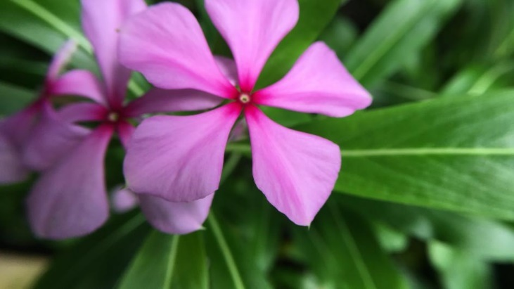
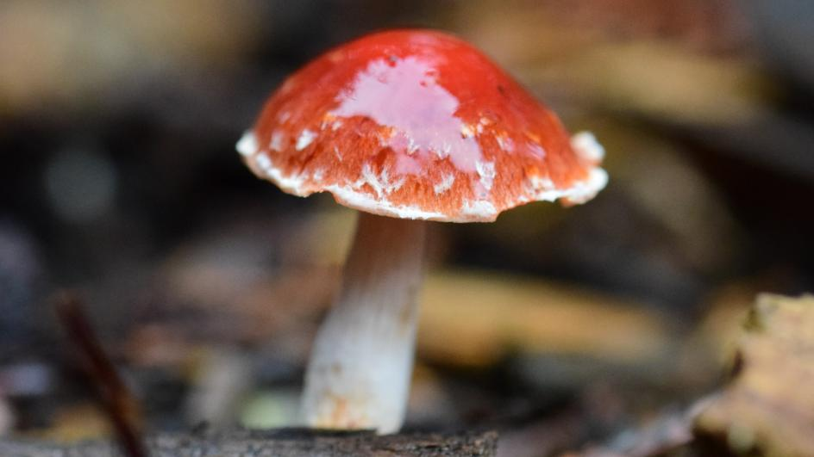
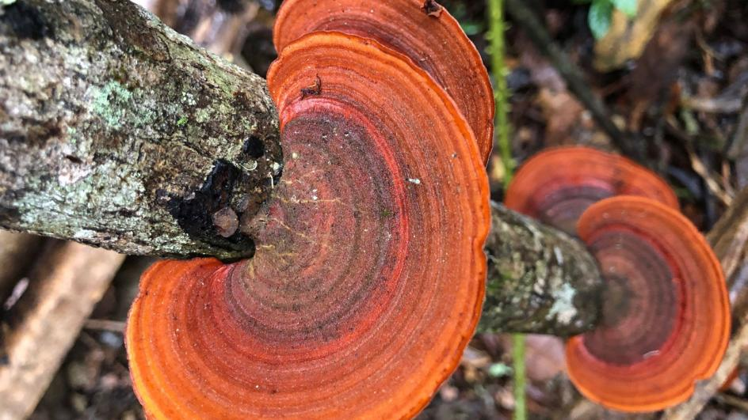
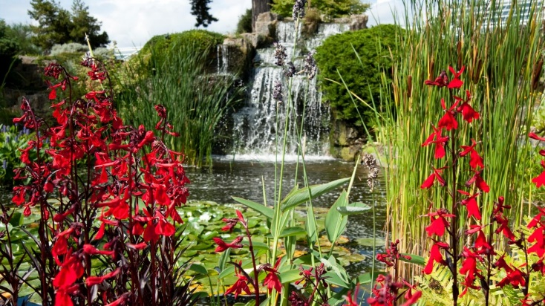
Make a Poster on any of the plants and list all the interesting facts that you have learnt.
Why did you pick the profile and what would you do to tell nature?

Plant profiles
Delve into our collection of plant profiles and feed your fascination with a wealth of plant uses, fun facts, and Kew's valuable work.
www.kew.org/plants

Kew Gardens

