Kew Gardens

Welcome to Royal Botanic Gardens, Kew
Unlock the amazing power of plants and fungi. Visit our world-leading botanic gardens and discover our science and conservation work.

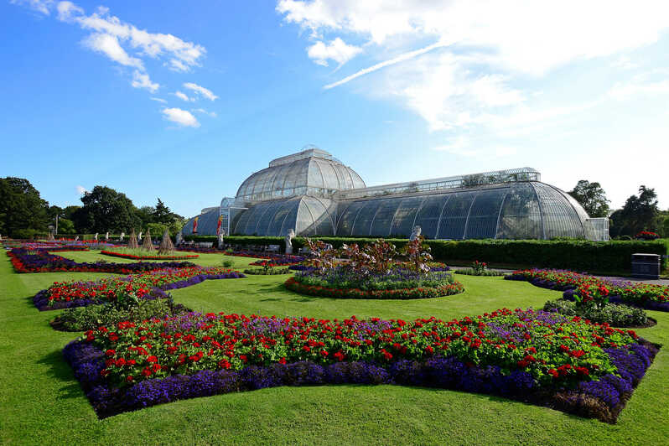
Expand your knowledge on plant and fungal science from the world's best experts.
www.kew.org/about-us/virtual-kew-wakehurst
Have

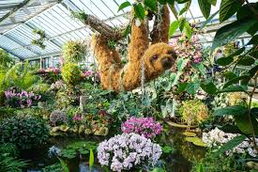
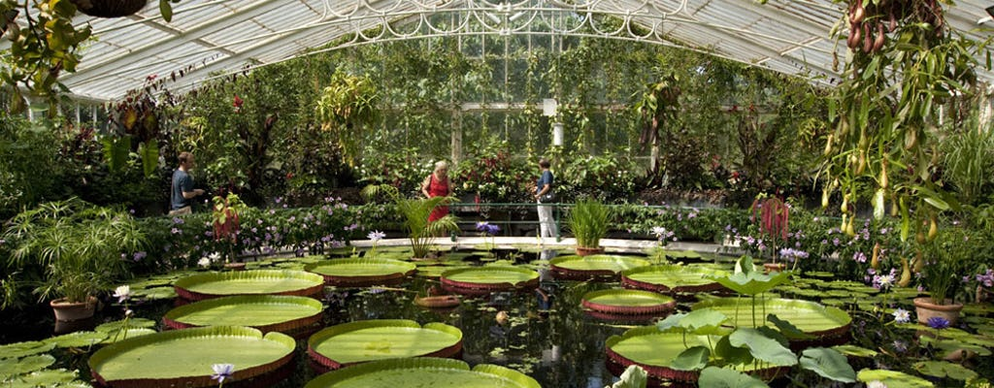
www.kew.org/about-us/virtual-kew-wakehurst/unearthed-kew-podcast
Have a browse through the podcasts and discover interesting facts and information about what happens at Kew Gardens.

