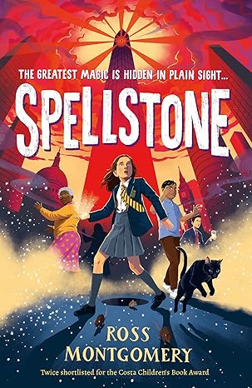
Dear Parents/Carers
The Big Read 2026 – Spellstone by Ross Montgomery
As you may have heard, the government have designated 2026 as a National Year of Reading. We are starting the year off by introducing our TMSA Big Read for 2026 – Spellstone by Ross Montgomery. Spellstone is a magical adventure exploring themes of friendship, teamwork and sacrifice which includes a diverse cast of characters including a talking cat! The main character Evie demonstrates all our school values throughout the story, particularly courage and kindness.
We will be running competitions and activities throughout the school year relating to the book and the author has sent us a video introducing the book which you can watch on our website here.
The Big Read is a scheme which we hope will involve the entire Marlborough community of students, staff, parents, and governors, reading a single book by the end of this school year. In previous years we have explored the Big Read in Drama, Art, English, History, Geography and MFL. This year we hope to extend this to more subject areas.
We are encouraging as many families as possible to buy their own copy of the book which is widely available; the paperback version RRP is £7.99 and can be purchased for a discounted price of £6 from school.
Copies can be ordered via School Gateway and will be available to collect from the LRC.
If you are registered or have previously been registered for free school meals, please contact Mrs Sen 01727 731341 as there is funding available for those students.
The book can also be purchased on Kindle currently at £6.49 or Kobo at £5.99 for an ebook or £9.99 for an audiobook and we have multiple copies available to borrow from the LRC. We will also be producing our own audiobook version with staff reading a chapter each and uploading to Google Classroom.
All students and staff who read the book and pass the Accelerated Reader quiz will contribute to a house competition.
We would like all who read the book to feed back their thoughts. Students will be given the opportunity to complete review sheets which we will collect and use for display purposes and publish on our Instagram page.
Those who hand in a completed review sheet will also be presented with a pin badge, to show their participation.
We do hope that this initiative will help to promote a love of reading. Not only is it an important skill to develop, reading for pleasure is also a fantastic form of relaxation and escapism; it builds a sense of community by allowing individuals to connect over sharing their experience and opinion of the book. In addition, regular reading can improve literacy and extend vocabulary. Research from The London School of Economics and Political Science, published in February 2025, emphasises the importance of reading for pleasure for improved wellbeing as well as academic progress.
We look forward to your support in making this initiative a success and I would like to urge all parents and carers to join us in reading the book whilst engaging in conversations with your children and other parents.
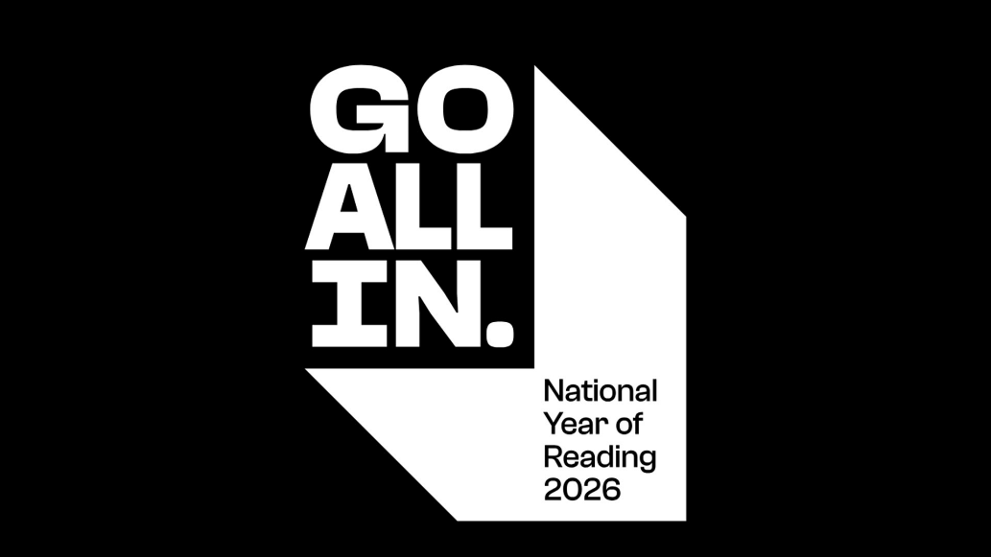
Yours sincerely

Mrs S Nixon
LRC Manager

