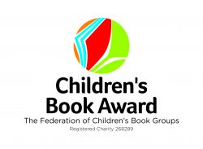
14th April 2026

Dear Parent/Carer,
Re: Children’s Book Award discussion morning – Wednesday 29th April 2026 - Beaumont School
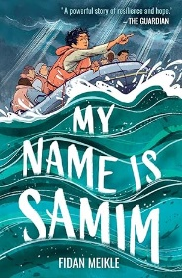
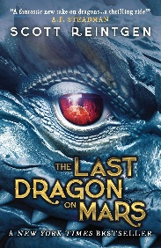
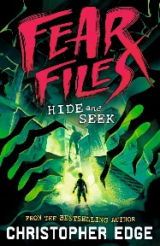
Your child has been reading the short list for the Federation of Children’s Book Groups Children’s Book Award. On Wednesday 29th April, we will be visiting Beaumont School to participate in a morning of activities based around the shortlist with students from other schools.

Author Sarah Hagger-Holt will be joining us for the event and there will be an opportunity for students to purchase signed copies of her books on the day. Independent book seller Terrie Bourner will be managing book sales, with all titles offered at £0.99 below the recommended retail price:
- The Fight That Makes Us - £7.00
- Just Like Everyone Else - £7.00
- Proud of Me - £6.00
- Nothing Ever Happens Here - £7.00

We will be leaving the school premises at the beginning of period 2 and returning during lunch. There will be snacks and drinks provided. All students need to be in full school uniform. There is no charge for this trip, but if students wish to purchase books, they will need to bring cash with them. You can find out more about Sarah and her books on her website here

This event is organised on behalf of Herts Children's Book Group and photos taken may be used on their social media and that of the other schools involved in addition to our school accounts. Consent must be given if you wish for your child to attend and this can be given via school gateway.

If you have any questions regarding the trip, please do not hesitate to contact me.

Best wishes
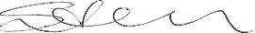

Mrs Nixon
LRC Manager

