Summer School August 2021

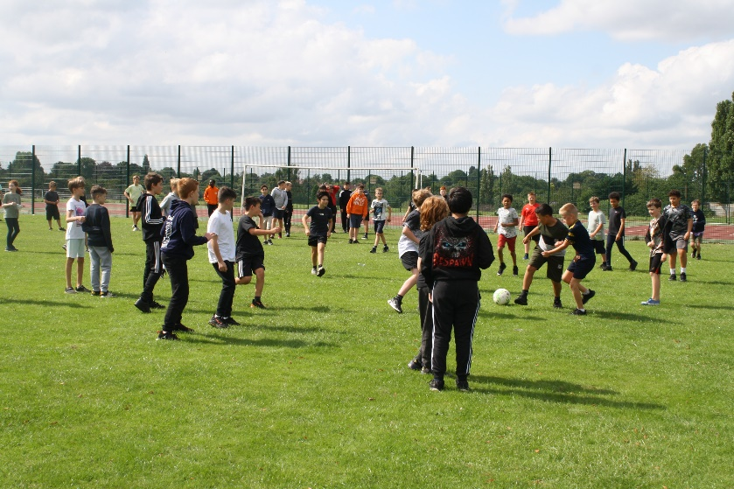

Summer School at the Marlborough Science Academy this year was run by Teachus Campus. Their summer camp programme aims to help students transition from primary to secondary school through exciting, engaging and innovative academic and recreational activities. A fun and enriched academic curriculum developed by leading academic professionals, allowing students the right set of tools to begin their new school! Their programme has been designed to allow students to take part in extra curricula activities ranging from sports, drama to well planned and highly rated day trips where the fun never ends!

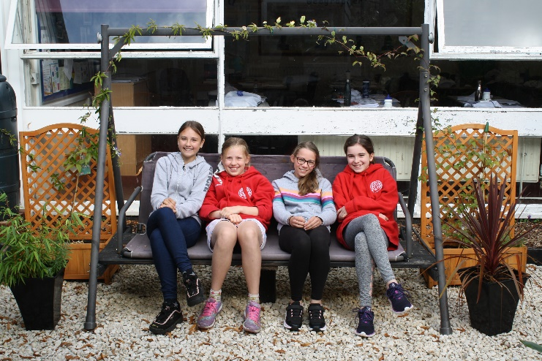

In accordance with the conditions of the funding we have provided below brief details of our summer camp. Our summer camp ran for 5 days between 23/08/21 to 27/08/21. Teachus Campus worked with us to organise the logistics and deliver the camp.

Their fees per student were £298.50 per week. Within this they provided:

- Teachers to conduct Maths and English lessons.

- Structured programme of study.

- Stationary, workbooks, drawstring bag, scientific calculator and reusable water bottles.

- Drama and ice breaker activities.

- Fitness activities

- Marketing – Inform and register students for the Summer School programme.

- PC Tablets

- Assessments

- One Day Trip

- Catering for all students and staff attending the programme

- First aid staff

- Administrative staff

